LABORATORY MANUAL
BASIC ELECTRICAL ENGINEERING

II B.TECH -I Semester (ECE)

AY-2018-2019
Prepared by

Lab In-charge: E.Sreenivasulu


Department of Electronics & Communication Engineering

II YEAR. B.Tech. ECE- I SEM L T/P/D C 0 -/3/- 2
(EC308ES) BASIC ELECTRICAL ENGINEERING LAB
LIST OF EXPERIMENTS (12 Experiments to be done)

PART – A

- Verification of KCL & KVL.
- Series & Parallel resonance-Timing, Resonant frequency, Bandwidth and Q-factor determination for RLC network.
- Time response of first order RC/RL network for periodic non sinusoidal input-
Time constant and steady state error determination.
- Two port network parameters-Z, Y Parameters, chain matrix and analytical verification.
- Two port network parameters- ABCD and h-Parameters
- Verification of Superposition and Reciprocity theorems
7. Verification of maximum power transfer theorem. Verification on DC, verification on AC with Resistive and Reactive loads.
8. Experimental determination of Thevenin’s and Norton’s equivalent circuits and verification by direct test

PART-B
1. Magnetization characteristics of D.C. Shunt generator. Determination of critical field resistance.
2. Swinburne’s Test on DC shunt machine (Predetermination of efficiency of a given DC Shunt machine working as motor and generator).
3. Brake test on DC shunt motor. Determination of performance characteristics.
4. OC & SC tests on Single-phase transformer (Predetermination of efficiency and regulation at given power factors and determination of equivalent circuit).
5. Brake test on 3-phase Induction motor (performance characteristics). 6. Regulation of alternator by synchronous impedance method.
6. Regulation of alternator by synchronous impedance method.
7. Load test on single phase transform

CERTIFICATE

This is to certify that this manual is a bonafide record of practical work in the BASIC ELECTRICAL ENGINEERING Laboratory in First Semester of second year B.Tech (ECE) programme during the academic year 2018-19. The book is prepared by E.Sreenivasulu assistant Professor, Department of Electronics and communication Engineering

Signature of HOD Signature of Director Signature of Principal

ACKNOWLEDGEMENT

It was really a good experience, working with Basic Electrical Engineering lab. First we would like to thank Mr.K.N.Bushan, Assoc.Professor, HOD of Department of Electrical and Electronics Engineering, MarriLaxman Reddy Institute of technology & Management for his concern and giving the technical support in preparing the document.
We are deeply indebted and gratefully acknowledge the constant support and valuable patronage of Dr.R.Kotaih, Director, MarriLaxman Reddy Institute of technology & Management for giving us this wonderful opportunity for preparing the Basic Electrical Engineering laboratory manual.
We express our hearty thanks to Dr.K.Venkateswara Reddy, Principal, MarriLaxman Reddy Institute of technology & Management, for timely corrections and scholarly guidance.
At last, but not the least I would like to thanks the entire EEE Department faculties those who had inspired and helped us to achieve our goal.

By

Mr.E.Sreenivasulu,
Asst.professor

GENERAL INSTRUCTIONS

1. Students are instructed to come to Basic Electrical Engineering laboratory on time. Late comers are not entertained in the lab.

2. Students should be punctual to the lab. If not, the conducted experiments will not be repeated.

3. Students are expected to come prepared at home with the experiments which are going to be performed.

4. Students are instructed to display their identity cards before entering into the lab.

5. Students are instructed not to bring mobile phones to the lab.

6. Any damage/loss of system parts like keyboard, mouse during the lab session, it is student’s responsibility and penalty or fine will be collected from the student.

7. Students should update the records and lab observation books session wise. Before leaving the lab the student should get his lab observation book signed by the faculty.

8. Students should submit the lab records by the next lab to the concerned faculty members in the staffroom for their correction and return.

9. Students should not move around the lab during the lab session.

10. If any emergency arises, the student should take the permission from faculty member concerned in written format.

11. The faculty members may suspend any student from the lab session on disciplinary grounds.

12. Never copy the output from other students. Write down your own outputs.

INSTITUTION VISION AND MISSION

VISION
To be as an ideal academic institution by graduating talented engineers to be ethically strong, competent with qualityresearch and technologies

MISSION
To fulfill the promised vision through the following strategic characteristics and aspirations:
- Utilize rigorous educational experiences to produce talented engineers
- Create an atmosphere that facilitates the success of students
- Programs that integrate global awareness, communication skills and Leadership qualities
- Education and Research partnership with institutions and industries to prepare the students for interdisciplinary research
DEPARTMENT VISION, MISSION , PROGRAMME EDUCATIONAL OBJECTIVES AND SPECIFIC OUTCOMES

VISION
To impart high qulality technical knowledge in Electrical nadlectronicsEngineerimg and to transform them imto globally competent engineers,researchers and entrepreneurs and to make them ethically,emotionally strong enough to meet the technological challenges, to excel globally and thus excel to greater hights in their career.

MISSION
- To toproidethe state of the art resources to achieve excellence in all apheres of Electrical Engineering related domains.
- To bridge the gap between academics and industries through proper teaching and learning processes .
- To inculcate moral and ethical values & environment among the students through knowledge centric education & research.
PROGRAMME EDUCATIONAL OBJECTIVES
The Programme Educational Objectives (PEOs) that are formulated for the Electrical engineering programme are listed below;

PEO1: Establish a successful professional career in industry, government or academia.
PEO2: Gain multidisciplinary knowledge providing a sustainable competitive edge in higher studies or Research.
PEO3: Promote design, analyze, and exhibit of products, through strong communication, leadership and ethical skills, to succeed an entrepreneurial.

PROGRAM SPECIFIC OUUTCOMES
PSO1: Applications of Computing: Ability to use knowledge in various domains to provide solution to new ideas and innovations.
PSO2: Programming Skills: Identify required technics, design suitable circuits, develop and maintaina design to built high efficiency Machines .
PROGRAMME OUT COMES
The Program Outcomes (POs) of the department are defined in a way that the Graduate Attributes are included, which can be seen in the Program Outcomes (POs) defined. The Program Outcomes (POs) of the department are as stated below:
a : An ability to apply knowledge of Science, Mathematics, Engineering & Computing fundamentals for the solutions of Complex Engineering problems.
b : An ability to identify, formulates, research literature and analyze complex engineering problems using first principles of mathematics and engineering sciences.
c : An ability to design solutions to complex process or program to meet desired needs.
d : Ability to use research-based knowledge and research methods including design of experiments to provide valid conclusions.
e : An ability to use appropriate techniques, skills and tools necessary for computing practice.
f : Ability to apply reasoning informed by the contextual knowledge to assess social issues, consequences & responsibilities relevant to the professional engineering practice.
g : Ability to understand the impact of engineering solutions in a global, economic, environmental, and societal context with sustainability.
h : An understanding of professional, ethical, Social issues and responsibilities.
i : An ability to function as an individual, and as a member or leader in diverse teams and in multidisciplinary settings.
j : An ability to communicate effectively on complex engineering activities within the engineering community.
k : Ability to demonstrate and understanding of the engineering and management principles as a member and leader in a team.
l : Ability to engage in independent and lifelong learning in the context of technological change.
COURSE STRUCTURE, OBJECTIVES & OUTCOMES

Laboratory subjects – Internal and external evaluation– Details of marks
Basic Electrical Engineering lab will have a continuous evaluation during 1stsemester for 25 sessional marks and 75 end semester examination marks.
Out of the 25 marks for internal evaluation, day-to-day work in the laboratory shall be evaluated for 15 marks and internal practical examination shall be evaluated for 10 marks conducted by the laboratory teacher concerned.

The end examination will be evaluated for a maximum of 75 marks.The end semester examination shall be conducted with an external examiner and internal examiner. The external examiner shall be appointed by the principal / Chief Controller of examinations

Course Objectives:
- To analyze a given network by applying various electrical laws and network theorems.
- To know the response of electrical circuits for different excitations.
- To calculate, Measure and know the relation between basic electrical parametres.
- To analyze the performance characteristics of DC and AC electrical machines.

Course Outcomes:
- Get an exposure to basic electrical laws.
- Understand the response of different types of electrical circuits to different excitations.
- Understand the measurement,calculation and relation between the basic electrical parameters.
- Understand the the basic characteristics of transformer and electrical mahiens.

Instructions to the students to conduct an experiment:

- Students are supposed to come to the lab with preparation, proper dress code and the set of tools required (1. Cutter, 2. Tester (small size), 3. Plier (6-Inches)).

- Dress code:

Boys: Shoe & Tuck.
Girls: Apron & Cut shoe.
- Don’t switch on the power supply without getting your circuit connections verified.

- Disciplinary action can be taken in the event of mishandling the equipment or switching on the power supply without faculty presence.

- All the apparatus taken should be returned to the Lab Assistant concerned, before leaving the lab.

- You have to get both your Observation book and your Record for a particular experiment corrected well before coming to the next experiment.

Guidelines to write your Observation book:

- Experiment title, Aim, Apparatus, Procedure should be right side.

- Circuit diagrams, Model graphs, Observations table, Calculations table should be left side.

- Theoretical and model calculations can be any side as per convenience.

- Result should always be at the end (i.e. there should be nothing written related to an experiment after its result).

- You have to write the information for all the experiments in your observation book.

- You are advised to leave sufficient no of pages between successive experiments in your observation book for the purpose of theoretical and model calculations.

Instructions to the students to conduct an experiment:

- Students are supposed to come to the lab with preparation, proper dress code and the set of tools required (1. Cutter, 2. Tester (small size), 3. Plier (6-Inches)).

- Dress code:

Boys: Shoe & Tuck. Girls: Apron & Cut shoe.
- Don’t switch on the power supply without getting your circuit connections verified.

- Disciplinary action can be taken in the event of mishandling the equipment or switching on the power supply without faculty presence.

- All the apparatus taken should be returned to the Lab Assistant concerned, before leaving the lab.

- You have to get both your Observation book and your Record for a particular experiment corrected well before coming to the next experiment.

Guidelines to write your Observation book:

- Experiment title, Aim, Apparatus, Procedure should be right side.

- Circuit diagrams, Model graphs, Observations table, Calculations table should be left side.

- Theoretical and model calculations can be any side as per convenience.

- Result should always be at the end (i.e. there should be nothing written related to an experiment after its result).

- You have to write the information for all the experiments in your observation book.

- You are advised to leave sufficient no of pages between successive experiments in your observation book for the purpose of theoretical and model calculations.

Expt No: 1

Verification of KVL and KCL.

Aim: To verify Kirchhoff’s Voltage Law and Kirchhoff’s Current Law theoretically and practically.

Apparatus:

S.No | Name of the equipment | Range | Type | Quantity
1. | Voltmeters | 0-20V | Digital | 4
2. | Ammeters | 0-200mA | Digital | 3
3. | DC Power Supply | 0-15V | Dual | 1
4. | Multimeter | ……….. | Digital | 4
5. | Kit board | ………. | ……. | 1 | 5.
6. | Connecting wires | ……….. | ……….. | as per need

Theory:

Kirchhoff's Laws
Kirchhoff's current law and voltage law, defined by Gustav Kirchhoff, describe the relation of values of currents that flow through a junction point and voltages in an electrical circuit loop, in an electrical circuit.

● Kirchhoff’s Current Law (KCL)

● Kirchhoff’s Voltage Law (KVL)

Kirchhoff's Current Law (KCL):
This is Kirchhoff's first law.
The sum of all currents that enter an electrical circuit junction is 0. When the currents enter the junction has positive sign and the current that leave the junction have negative sign: Another way to look at this law is that the sum of currents that enter a junction is equal to the sum of currents that leave the junction:

Kirchhoff's Voltage Law (KVL):
This is Kirchhoff's second law.
The directed sum of the electrical potential differences (voltage) around any closed network is zero.

Circuit Diagram of KVL:

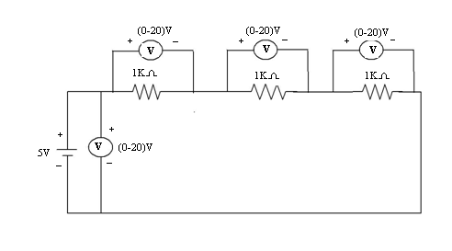

Circuit Diagram of KCL:

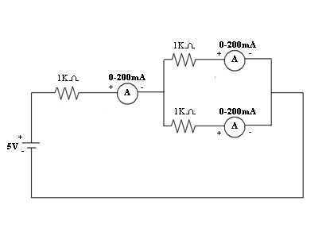

Procedure:

- To verify KVL, Connections are made as shown in the Fig-1

- Supply is given to the circuit and the readings of the voltmeters are noted down.

- Kirchhoff’s Voltage law can be verified by V_{s}=V₁+V₂+V₃(v).

- To verify KCL, Connections are made as shown in the Fig-2.

- Supply is given to the circuit and the readings of the Ammeters are noted down.

- Kirchhoff’s Current law can be verified by I=I₁+I₂(A).

Theoretical Calculations:

Observations Table:

 | V_{s}(V) | V₁(V) | V₂(V) | V₃(V) | V₁+V₂+V₃(V) |  | I(A) | I₁(A) | I₂(A) | I₁ +I₂(A)
Theoretical
Values
Practical
Values

Precautions:

- Making loose connections are to be avoided.

- Readings should be taken carefully without parallax error.

Result:

Applications:
1. Kirchhoff's Laws are applications of two fundamental conservation laws: the Law of Conservation of Energy, and the Law of Conservation of Charge.
2. The current distribution in various branches of a circuit can easily be found out by applying Kirchhoff Current law at different nodes or junction points in the circuit.
3. After that Kirchhoff Voltage law is applied, each possible loop in the circuit generates algebraic equation for every loop

VIVA QUESTIONS:
1. What is the statement of KVL?
2. What is the statement of KCL?
3. What is the statement of Ohm’s law?
4. Give the limitations of Kirchhoff’s laws?
5. What is the Condition of Ohm’s law?
6.Please Define Ohm’s Law for A.C (Alternating Current)?
7. What is Voltage Divider Rule?
8. What is Current Divider Rule (CDR)?
9. Differentiate between Kirchhoff’s First law and Kirchhoff’s Second law?
10. What is the function of Capacitor in Electrical Circuits?
11. Why Inductors are installed in electrical Circuits?
12. Briefly explain the purpose of Inductor in an electric circuit?
13. What do you mean by dependent and independent voltage sources?
14. Differentiate between ideal and non-ideal voltage sources?
15. What does the term “Voltage Regulation” means?
16.What is DC Current source? Differentiate between ideal and non ideal current sources?
17.What id difference between power and energy?
18. Define steady state?
19. Initial conditions of capacitors?
20.Explain how an inductor and capacitors behaves when AC&DC are given?
21.Initial conditions of inductance?
22.What is the difference between Voltage Divider Rule and current divider rule?
23.What is the function of an inductor in electrical circuits?
24.What is dependent voltage source?
25.What is independent voltage source?
26.On what bases KCL is based on?
27.kirchhoffs current law is applied at?
28.kirchhoffs voltage law is based on?
29.which law can be best suited for the analysis of circuit with more number of loops?
30.Mathematically KVL can written as?
31.What is an ideal current source?
32.How can a current source will be practically represented?
33.How can a voltage source will be practically represented?
34.What is a constant voltage source?
35.With some initial change at t=0+, a capacitor will act as?
36.Potential difference in electrical terminology is known as?
37.why inductors are installed in electrical Circuits?
38.What is an ideal voltage soure?
39.What is an non ideal voltage source?
40.What is meant by a power?
41.What is meant by current?
42.What is meant by a energy?
43.What is the difference between power and energy?
44.What is kirchhoffs second law?
45.How to calculate energy stored in an inductance?
46.How could you measure voltage in series?
47.What is the difference between inductor and capacitor?
48.Could you measure current in parallel?
49.what is the difference between voltages or potential difference?
50.How to calculate energy stored in capacitance?

EXERCISE PROBLEMS

- Two resistors each of 4Ω & 12Ω are connected in parallel and the parallel combination is connected in series with a 2 Ω resistor. If this circuit is connected across a 100V supply, find the total current drawn.

- A Wheatstone bridge ABCD is arranged as follows AB=1Ω, BC=2 Ω, CD=3 Ω , DA=4 Ω. A 4 volt battery is connected in between A and C. Find the current using KVL.

- A Wheatstone bridge ABCD is arranged as follows AB=2Ω, BC=4 Ω, CD=6 Ω , DA=8 Ω. A 6 volt battery is connected in between A and C. Find the current using KVL.

- A Wheatstone bridge ABCD is arranged as follows AB=3Ω, BC=6Ω, CD=8 Ω, DA=10Ω. An 8volt battery is connected in between A and C. Find the current using KVL.

- Two batteries A& B having emf”s 12V and 8V resp and internal resistances of 2Ω and 1 Ω resp, are connected in parallel across 10 Ω resistor calculate the current in each of the battery applying KVL.

- Two resistors each of 8Ω & 10Ω are connected in parallel and the parallel combination is connected in series with a 4 Ω resistor. If this circuit is connected across a 50V supply, find the total current drawn.

- A Wheatstone bridge ABCD is arranged as follows AB=6Ω, BC=4 Ω, CD=2 Ω, DA=1 Ω. A 6 volt battery is connected in between A and C. Find the current using KVL.

- A Wheatstone bridge ABCD is arranged as follows AB=10Ω, BC=8 Ω , CD=6 Ω , DA=4 Ω. A 10 volt battery is connected in between A and C. Find the current using KVL.

- A Wheatstone bridge ABCD is arranged as follows AB=3Ω, BC=6Ω, CD=9 Ω, DA=12Ω. A 12 volt battery is connected in between A and C. Find the current using KVL.

- Three batteries A,B&C having emf”s 15V,12V & 12V resp and internal resistances of 3Ω,4 Ω and 2 Ω resp, are connected in parallel across 15Ω resistor calculate the current in each of the battery applying KVL.

- Two resistors each of 6Ω & 10Ω are connected in parallel and the parallel combination is connected in series with a 6Ω resistor. If this circuit is connected across a 100V supply, find the total current drawn.

- A Wheatstone bridge ABCD is arranged as follows AB=2Ω, BC=2 Ω, CD=1 Ω , DA=4 Ω. A 5 volt battery is connected in between A and C. Find the current using KVL.

- A Wheatstone bridge ABCD is arranged as follows AB=5Ω, BC=6 Ω, CD=5Ω , DA=6 Ω. A 12 volt battery is connected in between A and C. Find the current using KVL.

- A Wheatstone bridge ABCD is arranged as follows AB=6Ω, BC=5Ω, CD=5 Ω, DA=12Ω. An 8volt battery is connected in between A and C. Find the current using KVL.

- Two batteries A& B having emf”s 12V and 15V resp and internal resistances of 5Ω and 4Ω resp, are connected in parallel across 12 Ω resistor calculate the current in each of the battery applying KVL.

- Two resistors each of 2Ω & 12Ω are connected in parallel and the parallel combination is connected in series with a 2 Ω resistor. If this circuit is connected across a 50V supply, find the total current drawn.

- A Wheatstone bridge ABCD is arranged as follows AB=5Ω, BC=5 Ω, CD=2Ω, DA=4Ω. A 10volt battery is connected in between A and C. Find the current using KVL.

- A Wheatstone bridge ABCD is arranged as follows AB=10Ω, BC=8 Ω , CD=6 Ω , DA=4 Ω. A 10 volt battery is connected in between A and C. Find the current using KVL.

- A Wheatstone bridge ABCD is arranged as follows AB=3Ω, BC=6Ω, CD=9 Ω, DA=12Ω. A 12 volt battery is connected in between A and C. Find the current using KVL.

- Two batteries A& B having emf”s 15V and 22V resp and internal resistances of 4Ω and 2 Ω resp, are connected in parallel across 15Ω resistor calculate the current in each of the battery applying KVL.

Expt. No: 2

Series and Parallel resonance

Aim: To verify Resonant Frequency, Bandwidth & Quality factor of RLC Series and Parallel Resonant circuits.

Apparatus:

S.No | Name of the equipment | Range | Type | Quantity
1. | CRO | (0-20)MHz | Dual | 1
2. | Series and parallel resonance kit |  |  | 1
3. | Connecting wires |  |  | as per need

Theory:

The voltage across the inductor is V_{L} = I X_{L}
the voltage across the capacitor is V_{C} = IX_{C}
the voltage across the resistor is V_{R} = IR
Phase relations among these voltages are shown in Figure 1 The voltage across the resistor is in phase with the current. The voltage across the inductor leads the current by 90 degrees.
The voltage across the capacitor lags the current by 90 degrees. The total voltage across the resistor, inductor and capacitor should be equal to the emf supplied by the generator.

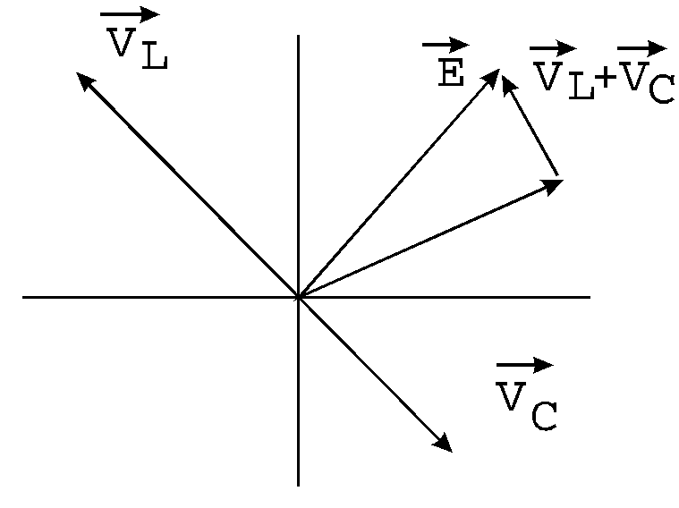
Figure 1
From Figure 2 we can see that
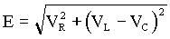
If we divide both sides of this equation by current, we will get
E/I = Z = R² + (X_{L} - X_{C}) ²,
Where (X_{L} - X_{C}) is called the total reactance and Z is called the impedance of the circuit.
We know that the capacitive reactance X_{C} = 1/ωC, and the inductive reactance X_{L} = ωL depend on frequency. The value of frequency when
X_{L} = X_{C}, ωL = 1/ωC, or
ω= 1/√LC = ω₀ = 2f₀
The frequency f₀ is called the resonance frequency of the circuit. At this frequency, the impedance is smallest and the maximum value of the current (and the voltage across the resistor V_{R}) can be obtained. At this frequency, the circuit is said to be at resonance. At resonance, the current is in phase with the generator voltage.
If we measure voltage across the resistor, depending on frequency, we will obtain a resonance curve of the circuit as shown in Figure2. A resonance curve can be characterized by the resonance width ∆f, the frequency difference between the two points on the curve where the power is half its maximum value or voltage is
V_{max}/√LC = 0.707 V_{max}
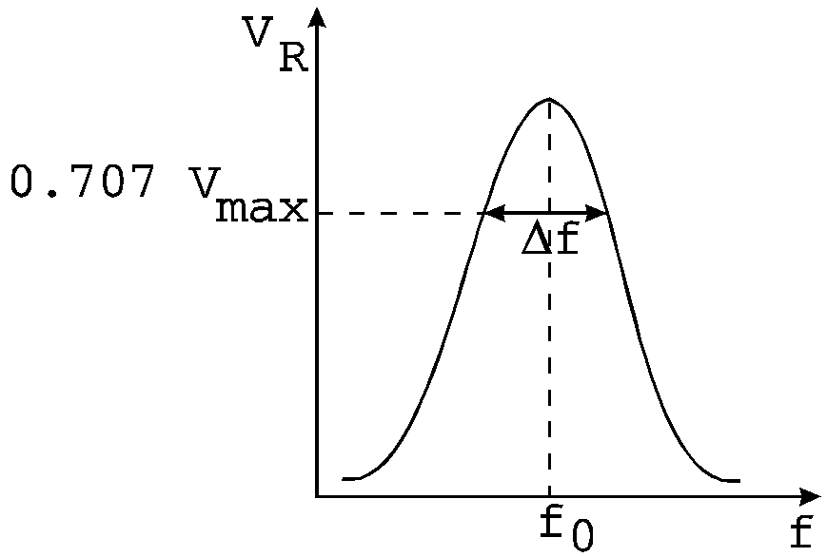
Figure 2
When the width is small compared with the resonance frequency, the resonance is sharp; that is, the resonance curve is narrow. The circuit can be characterized by the quality factor Q = f₀/∆f.
If resistance is small and resonance is sharp, the quality factor is large. When the resistor is large, the quality is small. Q is a measure of the rate at which energy is dissipated in the circuit if the AC voltage source across the series circuit was removed.

Parallel Resonance:

Theory:

The parallel RLC circuit is very common in radio and TV circuits. The circuit analysis follows from Kirchhoff’s laws, but is not in many beginning texts. The common terminal voltage V is across each element (see Fig. 3a), and the instantaneous current i is the algebraic sum of the instantaneous, i_{f}, and i_{c}.
Since i_{R} is in phase with V, but i_{L} lags V by 90⁰, and i_{c} leads V by 90⁰, we can describe the situation by the rotating vectors in Fig. 5b where I is the vector sum of I_{R}, I_{L}, and I_{C}. Hence from Fig 3b

Figure 3: A parallel LRC circuit.

Theoretical Calculations:

Formulae Required :

Series Resonance:

1. Resonant frequency, fo = ¹
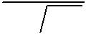
2π LC

- Quality factor, Q = X_{L}/R =2πf_{º}L/R

- Bandwidth, BW = f_{º}/Q
Parallel Resonance:
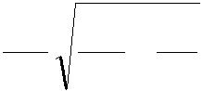
1. | Resonant frequency, f |  |  |  | o |  |  | = | 1 | 1 |  | − | R²
 |  |  |  |  |  |  |  |  | 2π | LC |  | − | L²
2. | Quality factor, Q = |  | R |  |  | = |  |  | R
2. |  |  |  |  |  |  |  |  | 2π f_{o}L
 |  |  | X_{L}
3. | Bandwidth, BW = | f_{o}
3. | Bandwidth, BW = | Q

Procedure:

Series Resonance:

- Circuit is connected as shown in the fig (1).

- A fixed voltage is applied to the circuit through function generator.

- The frequency is varied in steps and the corresponding ammeter reading is noted down as I_{s}.

- A graph is drawn between frequency f and current I_{s}. Resonant frequency (f_{o}) and Half power frequencies (f_{1,} f₂) are marked on the graph.

5. Bandwidth = (f₂-f_{1.}) & Quality factor Q = | f ₀ | are found from the graph.
5. Bandwidth = (f₂-f_{1.}) & Quality factor Q = | BW | are found from the graph.
6. Practical values of Resonant Frequency, Q-factor and Bandwidth are compared with theoretical values.

Parallel Resonance:

- Circuit is connected as shown in the fig (2)

- A fixed voltage is applied to the circuit through function generator.

- The frequency is varied in steps and the corresponding ammeter reading is noted down as I_{p}.

- A graph is drawn between frequency f and current I_{p}. Resonant Frequency (f_{o}) and Half power frequencies (f_{1,} f₂) are marked on the graph.

5. Bandwidth = (f₂-f_{1.}) & Quality factor Q = | f ₀ | are found from the graph.
5. Bandwidth = (f₂-f_{1.}) & Quality factor Q = | BW | are found from the graph.
6. Practical values of Resonant Frequency, Q-factor and Bandwidth are compared with theoretical values.

Circuit Diagram of Series Resonance:

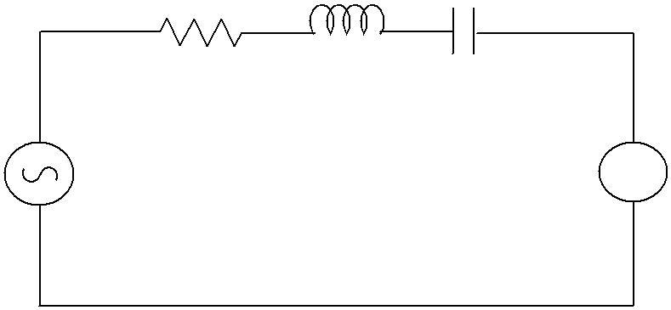
1kΩ 30mH 0.1µf

Signal generator A

Fig-1

Model Graph:

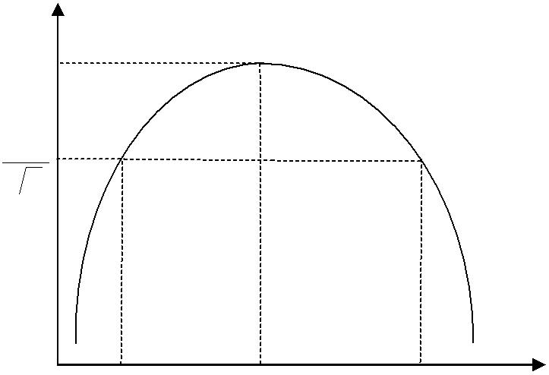
^{I}max

^{I}max 2

f₁ f₀ f₂ f(Hz)

Circuit Diagram of Parallel Resonance

1k Ω 30mH
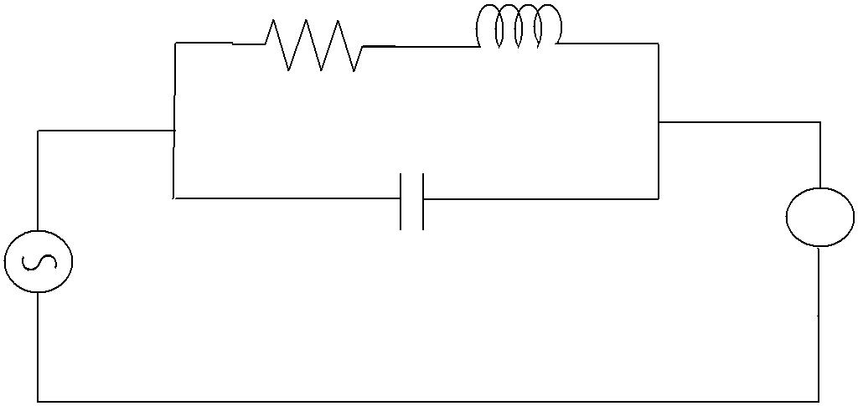

A
Vs 0.1µf

Fig-2

Model Graph:

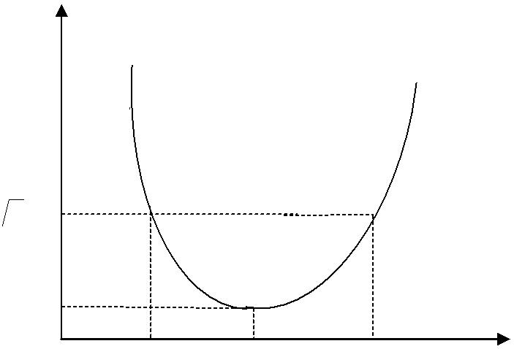
I_{P}

^{2I}min

^{I}min
f₁ f₀ f2 f (Hz)

Observations:

Series Resonance |  |  |  |  | Parallel Resonance
S.No. | Frequency (Hz) | Current(I_{s})  Amp |  | S.No. | Frequency (Hz) | Current(I_{p})Amp

Result Table:

 | Series Resonance |  | Parallel Resonance
 | Theoretical | Practical | Theoretical | Practical
Resonant frequency(f₀)Hz
Bandwidth(BW)
Quality factor(Q)
Precautions:

- Making loose connections are to be avoided.

- Readings should be taken carefully without parallax error.

Result:

Applications:
All mains operated appliances have switches that are connected to the live wire (the wire that carries current into the appliance). When a switch is in series with a device, it controls the device, allowing us to switch it on and off.
For example, often lawnmowers have two switches in series with each other so that both switches need to be pressed before the mower will turn on

Lighting circuits
In the lighting circuit all the lamps are connected in parallel

VIVA QUESTIONS:
- Define resonance?
- Difference between series & parallel resonance?
- Define band width?
- Define quality factor?
- What is the relation between bandwidth & quality factor?
- What is the lower &upper cutoff frequency?
- What is the formula for RC series network using laplace transform?
- Explain initial conditions of capacitance?
- Explain types of elements?
- Which capacitor is preferred for high voltage and frequency?
- What are the material used for resistor?
- What happens to voltage when current through the inductor is constant?
- How will you define capacitance?
- When we use 3 terminal resistor?
- What are the material used for inductance coil?
- Define Resonance and 3dB points?
- What is phase difference between voltage and current in inductor and capacitor?
- Define Selectivity, Bandwidth and Q-factor?
- For RLC circuit what is the power factor at the lowest frequency?
- What are the expressions for admittance, conductance and suceptance and also write its units?
- What is meant by resonance?
- What do you mean by sharpness of resonance
- What is resonance frequency?
- What are forced vibrations?
- What is bandwidth of series circuit?
- Define quality factor of a series circuit.
- Why should maximum value of current be divided by √2 for finding bandwidth?
- Why is the series circuit called as acceptor circuit
- Why parallel resonance circuit is called a rejecter circuit?
- What is the importance of series resonance circuits?
- What is the Q (Quality factor) of a series circuit that resonates at 6 kHz, has equal reactance of 4 kilo-ohms each, and a resistor value of 50 ohms?
- What is the range between f₁ and f₂ of an RLC circuit that resonates at 150 kHz and has a Q of 30?
- What is the quality factor?
- What effect will a parallel tank have upon final filter current?
- How much current will flow in a series RLC circuit when V_{T} = 100 V, X_{L} = 160 , X_{C} = 80 , and R =60 ?
- At resonance, the term bandwidth includes all frequencies that allow what percentage of maximum current to flow?
- What is the true power consumed in a 30 V series RLC circuit if Z = 20 ohms and R = 10 ohms?
- At any resonant frequency, what voltage is measured across the two series reactive components?
- Series RLC impedance or voltage totals must always be calculated by?
- What is the high cutoff frequency for an RLC circuit that resonates at 2000 Hz and has a bandwidth of 250 Hz?
- What is the band pass (F₁ – F₂) of an RLC filter that resonates at 150 kHz and has a coil Q of 30?
- What is the power factor?
- What is the phase angle?
- What would be the power factor for an RLC circuit that acts inductively?
- Voltage lags current in an RLC circuit when it acts:?
- Series RLC voltage or impedance totals must be calculated by
- When X_{C} = X_{L} the circuit:?
- How much current will flow in a series RLC circuit when V_{T} = 100 V, X_{L} = 160 , X_{C} = 80 , and R = 60 ?
- When a full band of frequencies is allowed to pass through a filter circuit to the output, the resonant circuit is called a:?
- At resonance, the term bandwidth includes all frequencies that allow what percentage of maximum current to flow?

EXERCISE PROBLEMS :

- To find the Resonant Frequency, Bandwidth & Quality factor of RLC
Series and Parallel Resonant circuits. (R=1KΩ, L=70mh, C=0.01µf).

2. To find the Resonant Frequency, Bandwidth & Quality factor of RLC
Series circuit. (R=1KΩ, L=30mh, C=0.01µf).

3. To find the Resonant Frequency, Bandwidth & Quality factor of RLC
Parallel circuit. (R=1KΩ, L=30mh, C=0.01µf).

4. To find the Resonant Frequency and Bandwidth of RLC Series circuit (R=2KΩ, L=30mh, C=0.01µf).

5. To find the Resonant Frequency and Bandwidth of RLC Parallel circuit (R=1KΩ, L=30mh, C=0.1µf).

6. To find the Resonant Frequency and Bandwidth of RLC Series circuit (R=1KΩ, L=100mh, C=0.1µf).

7. To find the Resonant Frequency and Bandwidth of RLC Series Parallel circuit (R=1KΩ, L=100mh, C=0.01µf).

8. To find the Resonant Frequency and Bandwidth of RLC Parallel circuit (R=5KΩ, L=100mh, C=0.001µf).

9. To find the Resonant Frequency and Bandwidth & band width of RLC Series circuit (R=1KΩ, L=70mh, C=0.01µf).

- To find the Resonant Frequency and Bandwidth of RLC Parallel circuit (R=2KΩ, L=100mh, C=0.1µf).

- To find the Resonant Frequency, Bandwidth & Quality factor of RLC
Series and Parallel Resonant circuits. (R=2KΩ, L=35mh, C=0.01µf).

12. To find the Resonant Frequency, Bandwidth & Quality factor of RLC
Series circuit. (R=2KΩ, L=60mh, C=0.01µf).

13. To find the Resonant Frequency, Bandwidth & Quality factor of RLC
Parallel circuit. (R=2KΩ, L=60mh, C=0.01µf).

14. To find the Resonant Frequency and Bandwidth of RLC Series circuit (R=4KΩ, L=60mh, C=0.01µf).

15. To find the Resonant Frequency and Bandwidth of RLC Parallel circuit (R=2KΩ, L=60mh, C=0.1µf).

16. To find the Resonant Frequency and Bandwidth of RLC Series circuit (R=2KΩ, L=200mh, C=0.1µf).

17. To find the Resonant Frequency and Bandwidth of RLC Series Parallel circuit (R=2KΩ, L=200mh, C=0.01µf).

18. To find the Resonant Frequency and Bandwidth of RLC Parallel circuit (R=5KΩ, L=100mh, C=0.001µf).

19. To find the Resonant Frequency and Bandwidth & band width of RLC Series circuit (R=2KΩ, L=35mh, C=0.01µf).

20. To find the Resonant Frequency and Bandwidth of RLC Parallel circuit (R=4KΩ, L=200mh, C=0.1µf).

Expt. No:3

Time response of Series RL and RC circuits

Aim: To draw the time response of first order series RL and RC network for periodic Non-Sinusoidal function and verify the time constant.

Apparatus:

S.No | Name of the equipment | Range | Type | Quantity
1. | Function generator | (0-100)MHz | digital | 1
2. | Decade Resistance box | -------- | ------------ | 1
3. | Decade Inductance box | -------- | ---------- | 1
4. | Decade Capacitance box | ----------- | ----------- | 1
5. | CRO | (0-20)MHz | Dual | 1
6. | CRO probes |  |  | 1
7. | Connecting wires |  |  | As required

Theory:

Theoretical Calculations:

Formulae required:

For RL Series circuit, Time constant,τ =
For RC Series circuit, Time constant, τ = RC

Circuit diagrams:

Series RL Circuit
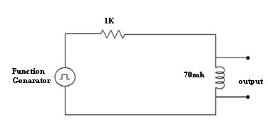

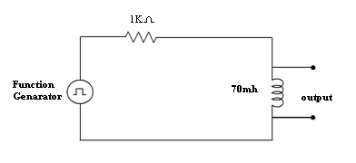

Series RC Circuit

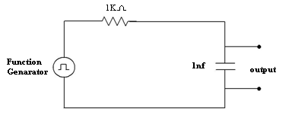

Model Graph:

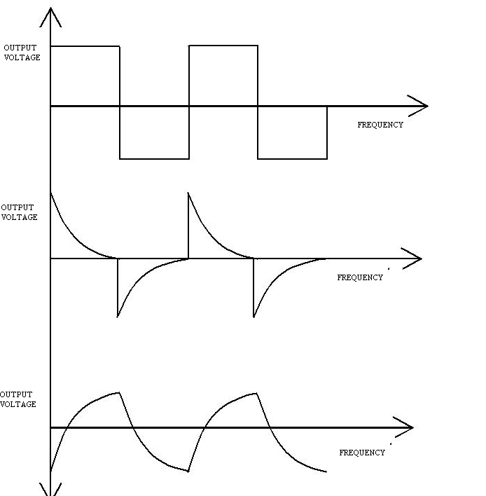

Procedure:

Series RL Circuit:

- Connections are made as shown in the fig-1.

- Input voltage (Square wave) is set to a particular value.

- The waveform of voltage across inductor is observed on CRO and the waveform is drawn on a graph sheet.

- The time constant is found from the graph and verified with the theoretical value.

Series RC Circuit:

- Connections are made as shown in the fig-2.

- Input voltage (Square wave) is set to a particular value.

- The waveform of voltage across the capacitor is observed on CRO and the waveform is drawn on a graph sheet.

- The time constant is found from the graph and verified with the theoretical value.

Result table:
 | Series RL Circuit |  | Series RC Circuit
 | Theoretical | Practical | Theoretical |  | Practical
Time Constant(τ)
Precautions:

- Making loose connections are to be avoided.

- Readings should be taken carefully without parallax error.

Result:

Applications:
- The two fundamental applications/operations of RC circuits are as: filter circuits, in the frequency domain; as timing circuits, in the time domain
- Whenever current flows through the coil, lines of magnetic flux are generated around it . this magnetic flux opposes changes in the current due to induced emf.that component is inductors
- What they are used for besides spark plugs. any help would be greatly appreciated or a nudge in the right direction

VIVA QUESTIONS:
1. Define the terms
i) Time response ii) Frequency response
2. Define the terms
i) Transient state ii) Steady state response
3. Define damping ratio?
4. Define Transient time?
5. Explain the different regions in frequency response?
6. State the frequency for RC phase shift oscillator?
7. what do you mean by a Conductivity?
8. Define resonance?
9. What is the phase difference between voltage and current in a capacitor? Which is leading?
10. What is the phase difference between voltage and current in a inductor? Which is leading?
11. What is the effect of resistance in RLC circuit?
12. For RLC circuit what is power factor at lowest powerfrequency ?
13. What is the locus of voltage phaser across R in series RLC circuit?
14. Define bandwidth?
15. Define cuttoff frequency?
16. Differentiate between transient state, transient time and transient response?
17. Define natural response and natural frequency?
18. Define time constants for RC and RL circuits?
19. What is meant by rise time, settling time and delay time?
20. What is meant by damping ratio?
21. Define the terms
i) Time response ii) Frequency response
22. Define the terms
i) Transient state ii) Steady state response
23. Define damping ratio?
24. Define Transient time?
25.Why should maximum value of current be divided by √2 for finding bandwidth?
26.Why is the series circuit called as acceptor circuit
27. what do you mean by a Conductivity?
28. Define resonance?
29. What is the phase difference between voltage and current in a capacitor? Which is leading?
31. What is the phase difference between voltage and current in a inductor? Which is leading?
32. What is the effect of resistance in RLC circuit?
33. For RLC circuit what is power factor at lowest powerfrequency ?
34. What is the locus of voltage phaser across R in series RLC circuit?
35. Define bandwidth?
36. Define cuttoff frequency?
37. Differentiate between transient state, transient time and transient response?
38. Define natural response and natural frequency?
39. Define time constants for RC and RL circuits?
40. What is meant by rise time, settling time and delay time?
41. What is meant by damping ratio?
42. Define Selectivity, Bandwidth and Q-factor?
43. For RLC circuit what is the power factor at the lowest frequency?
44. What are the expressions for admittance, conductance and suceptance and also write
its units?
45.What is meant by resonance?
46.What do you mean by sharpness of resonance
47.What is resonance frequency?
48.What are forced vibrations?
49.What is bandwidth of series circuit?
50.Define quality factor of a series circuit.

EXCERSISE PROBLEMS:

1. To draw the time response of first order series RL and RC network (R=1KΩ, L=30mh,c=0.01µf )for periodic Non-Sinusoidal function and verify the time constant.
2. To draw the time response of first order series RL and RC network (R=2KΩ, L=40mh,c=0.021µf )for periodic Non-Sinusoidal function and verify the time constant.
3. To draw the time response of first order series RL and RC network (R=3KΩ, L=30mh,c=0.01µf )for periodic Non-Sinusoidal function and verify the time constant.
4. To draw the time response of first order series RL and RC network (R=1KΩ, L=40mh,c=0.01µf )for periodic Non-Sinusoidal function and verify the time constant.
5. To draw the time response of first order series RL and RC network (R=1KΩ, L=40mh,c=0.31µf )for periodic Non-Sinusoidal function and verify the time constant.
6. To draw the time response of first order series RL and RC network (R=1KΩ, L=40mh,c=0.11µf )for periodic Non-Sinusoidal function and verify the time constant.
7. To draw the time response of first order series RL and RC network (R=2KΩ, L=40mh,c=0.02µf )for periodic Non-Sinusoidal function and verify the time constant.
8. To draw the time response of first order series RL and RC network (R=1KΩ, L=33mh,c=0.21µf )for periodic Non-Sinusoidal function and verify the time constant.
9. To draw the time response of first order series RL and RC network (R=3KΩ, L=40mh,c=0.21µf )for periodic Non-Sinusoidal function and verify the time constant.
10. To draw the time response of first order series RL and RC network (R=2KΩ, L=35mh,c=0.36µf )for periodic Non-Sinusoidal function and verify the time constant.
11. To draw the time response of first order series RL and RC network (R=2KΩ, L=60mh,c=0.01µf )for periodic Non-Sinusoidal function and verify the time constant.
12. To draw the time response of first order series RL and RC network (R=4KΩ, L=80mh,c=0.021µf )for periodic Non-Sinusoidal function and verify the time constant.
13. To draw the time response of first order series RL and RC network (R=6KΩ, L=60mh,c=0.01µf )for periodic Non-Sinusoidal function and verify the time constant.
14. To draw the time response of first order series RL and RC network (R=2KΩ, L=80mh,c=0.01µf )for periodic Non-Sinusoidal function and verify the time constant.
15. To draw the time response of first order series RL and RC network (R=2KΩ, L=80mh,c=0.31µf )for periodic Non-Sinusoidal function and verify the time constant.
16. To draw the time response of first order series RL and RC network (R=2KΩ, L=80mh,c=0.11µf )for periodic Non-Sinusoidal function and verify the time constant.
17. To draw the time response of first order series RL and RC network (R=4KΩ, L=80mh,c=0.02µf )for periodic Non-Sinusoidal function and verify the time constant.
18. To draw the time response of first order series RL and RC network (R=2KΩ, L=66mh,c=0.21µf )for periodic Non-Sinusoidal function and verify the time constant.
19. To draw the time response of first order series RL and RC network (R=6KΩ, L=80mh,c=0.21µf )for periodic Non-Sinusoidal function and verify the time constant.
20. To draw the time response of first order series RL and RC network (R=4KΩ, L=70mh,c=0.36µf )for periodic Non-Sinusoidal function and verify the time constant.

Expt. No:4

Two port network parameters (Z, Y parameters)

Aim: To obtain experimentally Z, Y parameters and of a given two port network.

Apparatus:

S.No | Name of the equipment | Range | Type | Quantity
1. | Ammeter | (0-200)mA | Digital | 2
2. | Voltmeter | (0-20)V | Digital | 2
3. | DC Power Supply | (0-30)V | Dual | 1
4. | Digital Multimeter |  | digital | 2
5. | Connecting wires |  |  | as per need

Theory:

To represent the general nature of a network, it is normally represented by a rectangular box. If a conductor is fastened to a node in the network and brought for access the end of the conductor is called a terminal. Terminals are required for connecting driving force to the network, for connecting load or making measurements.
The minimum number of terminals that are useful are two. One pair of terminals is given the name Port. In the two port network shown in fig 1 we have four variable identified by two voltages and two currents. We assume that the variables transform quantities and use V1 and I1 as variables at the input port 1, V2 and I2 as the variables at the output port 2. Now only two of the four variables are independent and the specific action of any two of them determines the remaining two.

Theoretical Calculations:

1) Z-parameters
The Z-parameters are also called as Impedance parameters.Z_{11,}Z₁₂ ,Z₂₁ ,Z₂₂
are the Z-parameters of the two port network..
V1= Z₁₁I1 + Z₁₂I2
V2= Z₂₁I1 + Z₂₂I2
- Input Impedance (Z₁₁) Z₁₁ is the input impedance when output is open circuited.
Z₁₁ = V1/I1 when I2=0
To measure Z₁₁ open circuit the output side of the two port network and apply voltage in the input side of the two port network then measure the V1 and I1 and substitute in the above equation.
- Reverse Transfer Impedance (Z₁₂) Z₁₂ is the mutual or reverse transfer impedance when input is open circuited.
Z₁₂ = V1/I2 when I1=0
To measure Z₁₂ open circuit the input side of the two port network and apply voltage in the output side of the two port network then measure the V1 and I2 and substitute in the above equation.
- Forward Transfer Impedance (Z2₁) Z₂₁ is the mutual or forward transfer impedance when output is open circuited.
Z₂₁ = V2/I1 when I2=0
To measure Z₂₁ open circuit the output side of the two port network and apply voltage in the input side of the two port network then measure the V2 and I1 and substitute in the above equation.

- Output Impedance (Z₂₂) Z₂₂ is the output impedance when output is open circuited.
Z₂₂ = V2/I2 when I1=0
To measure Z₂₂ open circuit the output side of the two port network and apply voltage in the input side of the two port network then measure the V2 and I2 and substitute in the above equation.
2) y-parameters
The Y-parameters are also called as Admittance parameters.Y_{11,}Y₁₂ ,Y₂₁ ,Y₂₂are the Y-parameters of the two port network..
I1= Y₁₁V1 + Y₁₂V2
I2= Y₂₁V1 + Y₂₂V2
- Input Admittance (Y₁₁) Y₁₁ is the input admittance when output is short circuited.
Y₁₁ = I1/V1 when V2=0
To measure Y₁₁ short circuit the output side of the two port network and apply voltage in the input side of the two port network then measure the V1 and I1 and substitute in the above equation.
- Reverse Transfer Admittance (Y₁₂) Y₁₂ is the mutual or reverse transfer admittance when input is short circuited.
Y₁₂ = I2/V1 when V2=0
To measure Y₁₂ short circuit the output side of the two port network and apply voltage in the input side of the two port network then measure the V1 and I2 and substitute in the above equation.
- Forward Transfer Admittance (Y₂₁) Y₂₁ is the mutual or forward transfer admittance when output is short circuited.
Y₂₁ = I1/V2 when V1=0
To measure Y₂₁ short circuit the input side of the two port network and apply voltage in the output side of the two port network then measure the V2 and I1 and substitute in the above equation.
- Output Admittance (Y₂₂) Y₂₂ is the output admittance when output is short circuited.
Y₂₂ = I2/V2 when V1=0
To measure Z₂₂ short circuit the input side of the two port network and apply voltage in the output side of the two port network then measure the V2 and I2 and substitute in the above equation.

Circuit diagram:

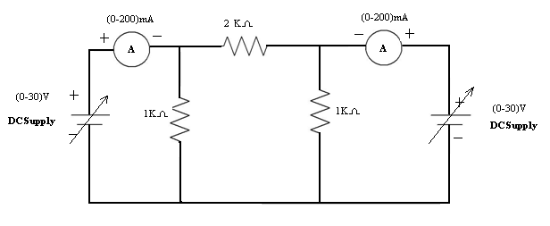

Procedure:

- Open Circuiting Output Terminals (I₂ = 0):

  - Connections are made shown in fig (1).

  - Supply is given to input port.

  - The readings of ammeter as I₁ and Voltmeter as V₂ are noted down.

2. Short circuiting output terminals (V₂ = 0):

  - Connections are made shown in fig (2).

  - Supply is given to input port.

  - The readings of ammeters as I₁& I₂ are noted down.

Observations:

When I₁=0

S.No. | V1(V) | I ₂(A) | V₂(V)
When I₂=0
S.No. | V₁(V) | I ₁(A) | V₂(V)

When V₁=0

S.No. | I ₂(A) | I 1(A) | V₂(V)

When V₂=0

S.No. | V1(V) | I₁(A) | I₂(A)

Result table:

 |  | Z Parameters |  |  |  |  |  |  |  |  | Y Parameters
 | Z11 (Ω) | Z12(Ω) |  | Z21(Ω) |  |  | Z22(Ω) |  | Y11(ᶷ) |  | Y12(ᶷ) |  | Y21(ᶷ) |  | Y22(ᶷ)
Theoretical
Practical

Precautions:

- Making loose connections are to be avoided.

- Readings should be taken carefully without parallax error.

Result:

Applications:
- h parameters were developed for use with bipolar transistor, and the individual parameters of the set closely match key parameters of the BJT
- y parameters are used for high frequency transistors, because they are easy to measure at high frequencies
- All of these parameter sets can be used to analyze an electronic circuit
- These parameters are used to describe the electrical behavior of linear electrical networks. They are also used to describe the small-signal (linearized) response of non-linear networks.
VIVA QUESTIONS:
- What are the equations of open circuit parameters?
- How can we obtain the short circuit parameters?
- What are transmission parameters?
- What are the equations of hybrid parameters?
- What is the condition for symmetry and condition for reciprocity in two port network parameters?
- Define branch?
- Which parameter is leading in parallel RC circuit?
- Why parallel circuit is called rejector?
- What is the formula for current i(t) in RC series?
- Derive RC series network using DE?
11. What is transfer impedance?
12. Why Z-parameters are used?
1 3. What are applications of Z and Y parameters?
14. What are relations used in Z parameters?
15. What is the relation between Z and Y parameters?
16. To obtain experimentally Z, Y parameters and of a given two port ∏ network
(R=4KΩ, 2KΩ, 2KΩ).
17. To obtain experimentally Z, parameters and of a given two portT network
(R=1KΩ, 2KΩ, 2KΩ).
18. To obtain experimentally Y parameters and of a given two port T network
(R=2KΩ, 1KΩ, 2KΩ).
19. To obtain experimentally Z, Y parameters and of a given two port ∏ network
(R=1KΩ, 2KΩ, 2 KΩ).
20. To obtain experimentally Y parameters and of a given two portT network
(R=3KΩ, 5KΩ, 6KΩ).
21. To obtain experimentally Z, Y parameters and of a given two port ∏ network
(R=4KΩ, 8KΩ, 8KΩ).
22. To obtain experimentally Z, parameters and of a given two port∏ network
(R=3KΩ, 2KΩ, 2KΩ).
23. To obtain experimentally Y parameters and of a given two port T Network

(R=4KΩ, 6KΩ, 7KΩ).
24. To obtain experimentally Z, Y parameters and of a given two port∏ network
(R=4KΩ, 2KΩ, 2KΩ).
25. To obtain experimentally Z, Y parameters and of a given two port T network
(R=4KΩ, 12KΩ, 10KΩ).
26. To obtain experimentally Z, Y parameters and of a given two port ∏ network
(R=2KΩ, 4KΩ, 6KΩ).
27. To obtain experimentally Z, parameters and of a given two portT network
(R=2KΩ, 4KΩ, 2KΩ).
28. To obtain experimentally Y parameters and of a given two port T network
(R=4KΩ, 2KΩ, 4KΩ).
29. To obtain experimentally Z, Y parameters and of a given two port ∏ network
(R=4KΩ, 2KΩ, 2KΩ).
30. To obtain experimentally Y parameters and of a given two portT network
(R=6KΩ, 4KΩ, 6KΩ).
31. To obtain experimentally Z, Y parameters and of a given two port ∏ network
(R=2KΩ, 2KΩ, 6KΩ).
32. To obtain experimentally Z, parameters and of a given two port∏ network
(R=6KΩ, 2KΩ, 2KΩ).
33. To obtain experimentally Y parameters and of a given two port T Network
(R=2KΩ, 5KΩ, 7KΩ).
34. To obtain experimentally Z, Y parameters and of a given two port∏ network
(R=2KΩ, 3KΩ, 2KΩ).
40. To obtain experimentally Z, Y parameters and of a given two port T network
(R=5KΩ, 12KΩ, 10KΩ)
41. Which quantity is same in series circuit?
42. Which quantity is same in parallel circuit?
43. What do you mean by resistance of a conductor?
44. What do you mean by ideal voltage source?
45. What do you mean by ideal current source?
46. What do you mean by practical voltage source?
47.What are applications of Z parameters?
48. Write the relations for Y parameters?
49. Write the relationship Y and Z-parameters?
50.What are applications of h-parameters?
EXCERSISE PROBLEMS

1. To obtain experimentally Z, Y parameters and of a given two port ∏ network
(R=4KΩ, 2KΩ, 2KΩ).
2. To obtain experimentally Z, parameters and of a given two portT network
(R=1KΩ, 2KΩ, 2KΩ).
3. To obtain experimentally Y parameters and of a given two port T network
(R=2KΩ, 1KΩ, 2KΩ).
4. To obtain experimentally Z, Y parameters and of a given two port ∏ network
(R=1KΩ, 2KΩ, 2 KΩ).
5. To obtain experimentally Y parameters and of a given two portT network
(R=3KΩ, 5KΩ, 6KΩ).
6. To obtain experimentally Z, Y parameters and of a given two port ∏ network
(R=4KΩ, 8KΩ, 8KΩ).
7. To obtain experimentally Z, parameters and of a given two port∏ network
(R=3KΩ, 2KΩ, 2KΩ).
8. To obtain experimentally Y parameters and of a given two port T Network
(R=4KΩ, 6KΩ, 7KΩ).
9. To obtain experimentally Z, Y parameters and of a given two port∏ network
(R=4KΩ, 2KΩ, 2KΩ).
10. To obtain experimentally Z, Y parameters and of a given two port T network
(R=4KΩ, 12KΩ, 10KΩ).
11.To obtain experimentally Z, Y parameters and of a given two port ∏ network
(R=2KΩ, 4KΩ, 6KΩ).
12. To obtain experimentally Z, parameters and of a given two portT network
(R=2KΩ, 4KΩ, 2KΩ).
13. To obtain experimentally Y parameters and of a given two port T network
(R=4KΩ, 2KΩ, 4KΩ).
14. To obtain experimentally Z, Y parameters and of a given two port ∏ network
(R=4KΩ, 2KΩ, 2KΩ).
15. To obtain experimentally Y parameters and of a given two portT network
(R=6KΩ, 4KΩ, 6KΩ).
16. To obtain experimentally Z, Y parameters and of a given two port ∏ network
(R=2KΩ, 2KΩ, 6KΩ).
17. To obtain experimentally Z, parameters and of a given two port∏ network
(R=6KΩ, 2KΩ, 2KΩ).
18. To obtain experimentally Y parameters and of a given two port T Network
(R=2KΩ, 5KΩ, 7KΩ).
19. To obtain experimentally Z, Y parameters and of a given two port∏ network
(R=2KΩ, 3KΩ, 2KΩ).
20. To obtain experimentally Z, Y parameters and of a given two port T network
(R=5KΩ, 12KΩ, 10KΩ).

Expt. No:5

Two port network parameters (ABCD and Hybrid parameters)

Aim: To obtain experimentally ABCD and h-parameters and of a given two port network.

Apparatus:

S.No | Name of the equipment | Range | Type | Quantity
1. | Ammeter | (0-200)mA | Digital | 2
2. | Voltmeter | (0-20)V | Digital | 2
3. | DC Power Supply | (0-30)V | Dual | 1
4. | Digital Multimeter |  | digital | 2
5. | Connecting wires |  |  | as per need

Theory:

H-parameters
The H-parameters are also called as Hybrid parameters. H11, H12, H21, H22are the H-parameters of the two port network..
V1= H₁₁I1 + H₁₂V2
I2= H₂₁I1 + H₂₂V2
- Input Impedance (H₁₁) H₁₁ is the input impedance when output is short circuited.
Z₁₁ = V1/I1 when V2=0
To measure H₁₁ short circuit the output side of the two port network and apply voltage in the input side of the two port network then measure the V1 and I1 and substitute in the above equation.
- Reverse Voltage Ratio (H₁₂) H₁₂ is the mutual or reverse transfer voltage ratio when input is open circuited.
H₁₂ = V1/I2 when I1=0
To measure Z₁₂ open circuit the input side of the two port network and apply voltage in the output side of the two port network then measure the V1 and I2 and substitute in the above equation.
- Forward Current Transfer Ratio (H₂₁) H₂₁ is the mutual or forward current transfer ratio when output is short circuited.
H₂₁ = I2/I1 when V2=0
To measure H₂₁ short circuit the output side of the two port network and apply voltage in the input side of the two port network then measure the I2 and I1 and substitute in the above equation.
- Output Admittance (H₂₂) H₂₂ is the output impedance when output is open circuited.
H₂₂ = I2/V2when I1=0
To measure H₂₂ open circuit the input side of the two port network and apply voltage in the output side of the two port network then measure the V2 and I2 and substitute in the above equation.
ABCD-parameters:
In this system of parameters voltage and current at port 1 are expressed in terms of voltage and current at port 2.
- A is defined as the ratio of input voltage to the output voltage when the output is open circuited.
A=V1/V2 when I2=0
- B is defined as the ratio of input voltage to the output current when output is short circuited.
B= V1/I2 when V2 =0
- C is defined as the ratio of input current to the output voltage when the output is open circuited.
C=I1/V2 when I2=0
- D is defined as the ratio of input current to the output current when output is short circuited.
D= I1/I2 when V2 =0

Theoretical Calculations:

Circuit diagram:

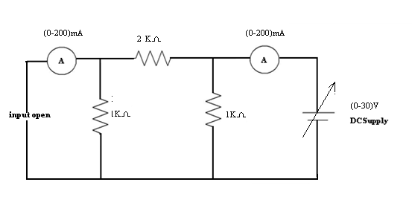

ABCD Parameters:

V₁ = AV₂ − BI₂

I₁ = CV₂ − DI₂

A = |  | V₁ |  |  |  |  |  |  |  | ; |  | C = |  |  | I₁
A = | V₂ |  |  |  |  |  |  |  |  |  |  |  | V₂
 |  |  |  |  |  |  | I₂ =0 |  |  |  |  |  |  |  |  |  |  |  |  |  | I₂ =0
B = − |  |  | V₁ |  |  |  |  |  |  |  |  | ; D |  | = − |  |  |  |  |  |  |  |  | I₁
 |  |  | I₂ |  |  |  |  |  |  | V =0 |  |  |  |  |  |  |  |  |  |  |  |  | I₂ |  |  |  |  |  |  | V =0
 |  |  |  |  |  |  |  |  |  | 2 |  |  |  |  |  |  |  |  |  |  |  |  |  |  |  |  | 2

Hybrid or h- Parameters:

V₁ = h₁₁I₁ + h₁₂V₂

I₂ = h₂₁I₁ + h₂₂V₂

^{h}11 | = | V₁ |  |  |  | ; | h₂₁ = |  | I ₂
^{h}11 | = | V₁ |  |  |  | ; | h₂₁ = |  | I₁
 |  | I₁ |  | V ₂ =0 |  |  |  |  | I₁ |  |  | V ₂ =0
^{h}12 | = | V₁ |  |  |  | ; | h₂₂ = |  | I ₂
^{h}12 | = | V₁ |  |  |  | ; | h₂₂ = | V ₂
 |  | V ₂ |  |  | I₁ =0 |  |  |  |  |  |  |  |  |  | I₁ =0

Procedure:

- Open circuiting input terminals (I₁ = 0):

  - Connections are made shown in fig (3).

  - Supply is given to output port.

  - The readings of ammeter as I₁ and Voltmeter as V₁ are noted down.

- Short circuiting input terminals (V₁=0):

  - Connections are made shown in fig (4).

  - Supply is given to output port.

  - The readings of ammeters as I₁& I₂ are noted down.

- The ABCD, Hybrid parameters are calculated using formulae and verified with theoretical values.

Observations:

When V₂=0

When I₁=0

S.No. | V1(V) | I ₂(A) | V₂(V)
When V₂=0

S.No. | V₁(V) | I ₁(A) | V₂(V)

When I₂=0

S.No. | V₁(V) | V₂(V) | I₁(A)

When V₂=0

S.No. | V1(V) | I₁(A) | I₂(A)

Result Table:

 |  | ABCD Parameters |  |  |  |  |  |  |  |  |  | Hybrid Parameters
 | A | B(Ω) |  | C(ᶷ) |  |  |  | D |  | h11(Ω) |  | h12 |  | h21 |  | h22(ᶷ)
Theoretical
Practical

Precautions:

- Making loose connections are to be avoided.

- Readings should be taken carefully without parallax error.

Result:

Applications:
- A major section of power system engineering deals in the transmission of electrical power from one particular place (eg. Generating station) to another like substations or distribution units with maximum efficiency
- h parameters were developed for use with bipolar transistor, and the individual parameters of the set closely match key parameters of the BJT
- All of these parameter sets can be used to analyze an electronic circuit
- ABCD parameters are extremely useful with cascaded linear passive networks (like multisection filters)

VIVA QUESTIONS :

- What are the equations of open circuit parameters?
- How can we obtain the short circuit parameters?
- What are transmission parameters?
- What are the equations of hybrid parameters?
- What is the condition for symmetry and condition for reciprocity in two port network parameters?
- Write Z-parameters in terms of hybrid parameters?
- Define port?
- What are the equation for hybrid parameters?
- What are the independent variables of ABCD parameters?
- Why impedence parameters are called as ope circuit parameters?
- Why Admittance parameters are called short circuit parameters?
- Give one real time application for all the four parameters?
- Mention dependent and independent variables for all parameters?
- Give the conditions for symmentry for z and h parameters?
- Convert z to y and y to h
- What are applications of ABCD parameters?
- Write the relations for ABCD parameters?
- Write the relationship ABCD and Z-parameters?
- What are applications of h-parameters?
- Write the relationship ABCD and h-parameters?
- To obtain experimentally Z, Y parameters and of a given two port ∏ network
(R=4KΩ, 2KΩ, 2KΩ).
22 .To obtain experimentally Z, parameters and of a given two portT network
(R=1KΩ, 2KΩ, 2KΩ).
23. To obtain experimentally Y parameters and of a given two port T network
(R=2KΩ, 1KΩ, 2KΩ).
24. To obtain experimentally Z, Y parameters and of a given two port ∏ network
(R=1KΩ, 2KΩ, 2 KΩ).
25. To obtain experimentally Y parameters and of a given two portT network
(R=3KΩ, 5KΩ, 6KΩ).
26. To obtain experimentally Z, Y parameters and of a given two port ∏ network
(R=4KΩ, 8KΩ, 8KΩ).
27. To obtain experimentally Z, parameters and of a given two port∏ network
(R=3KΩ, 2KΩ, 2KΩ).
28. To obtain experimentally Y parameters and of a given two port T Network

(R=4KΩ, 6KΩ, 7KΩ).
29. To obtain experimentally Z, Y parameters and of a given two port∏ network
(R=4KΩ, 2KΩ, 2KΩ).
30. To obtain experimentally Z, Y parameters and of a given two port T network
(R=4KΩ, 12KΩ, 10KΩ).
31.. To obtain experimentally Z, Y parameters and of a given two port ∏ network
(R=2KΩ, 4KΩ, 6KΩ).
32.. To obtain experimentally Z, parameters and of a given two portT network
(R=2KΩ, 4KΩ, 2KΩ).
33. To obtain experimentally Y parameters and of a given two port T network
(R=4KΩ, 2KΩ, 4KΩ).
34. To obtain experimentally Z, Y parameters and of a given two port ∏ network
(R=4KΩ, 2KΩ, 2KΩ).
35. To obtain experimentally Y parameters and of a given two portT network
(R=6KΩ, 4KΩ, 6KΩ).
36. To obtain experimentally Z, Y parameters and of a given two port ∏ network
(R=2KΩ, 2KΩ, 6KΩ).
37. To obtain experimentally Z, parameters and of a given two port∏ network
(R=6KΩ, 2KΩ, 2KΩ).
38. To obtain experimentally Y parameters and of a given two port T Network
(R=2KΩ, 5KΩ, 7KΩ).
39. To obtain experimentally Z, Y parameters and of a given two port∏ network
(R=2KΩ, 3KΩ, 2KΩ).
40. To obtain experimentally Z, Y parameters and of a given two port T network
(R=5KΩ, 12KΩ, 10KΩ).
41. Which quantity is same in series circuit?
42. Which quantity is same in parallel circuit?
43. What do you mean by resistance of a conductor?
44. What do you mean by ideal voltage source?
45. What do you mean by ideal current source?
46. What do you mean by practical voltage source?
47.What are applications of ABCD parameters?
48. Write the relations for ABCD parameters?
49. Write the relationship ABCD and Z-parameters?
50.What are applications of h-parameters?

EXCERSISE PROBLEMS

1. To obtain experimentally H , parameters and of a given two port ∏ network
(R=4KΩ, 2KΩ, 2KΩ).
2. To obtain experimentally H, parameters and of a given two portT network
(R=1KΩ, 2KΩ, 2KΩ).
3. To obtain experimentally ABCD parameters and of a given two port T network
(R=2KΩ, 1KΩ, 2KΩ).
4. To obtain experimentally ABCD parameters and of a given two port ∏ network
(R=1KΩ, 2KΩ, 3KΩ).
5. To obtain experimentally H parameters and of a given two portT network
(R=3KΩ, 5KΩ, 6KΩ).
6. To obtain experimentally ABCD parameters and of a given two port ∏ network
(R=4KΩ, 8KΩ, 8KΩ).
7. To obtain experimentally Z, parameters and of a given two port∏ network
(R=3KΩ, 2KΩ, 2KΩ).
8. To obtain experimentally H parameters and of a given two port T Network
(R=4KΩ, 6KΩ, 7KΩ).
9. To obtain experimentally ABCD and H parameters and of a given two port∏ network
(R=4KΩ, 2KΩ, 2KΩ).
10. To obtain experimentally H parameters and of a given two port T network
(R=4KΩ, 12KΩ, 10KΩ).
11.To obtain experimentally H , parameters and of a given two port ∏ network
(R=2KΩ, 7KΩ, 3KΩ).
12. To obtain experimentally H, parameters and of a given two portT network
(R=2KΩ, 3KΩ, 5KΩ).
13. To obtain experimentally ABCD parameters and of a given two port T network
(R=2KΩ, 1KΩ, 2KΩ).
14. To obtain experimentally ABCD parameters and of a given two port ∏ network
(R=2KΩ, 2KΩ, 3KΩ).
15. To obtain experimentally H parameters and of a given two portT network
(R=3KΩ, 4KΩ, 6KΩ).
16. To obtain experimentally ABCD parameters and of a given two port ∏ network
(R=4KΩ, 6KΩ, 8KΩ).
17. To obtain experimentally Z, parameters and of a given two port∏ network
(R=2KΩ, 4KΩ, 2KΩ).
18. To obtain experimentally H parameters and of a given two port T Network
(R=2KΩ, 6KΩ, 7KΩ).
19. To obtain experimentally ABCD and H parameters and of a given two port∏ network
(R=2KΩ, 5KΩ, 2KΩ).
20. To obtain experimentally H parameters and of a given two port T network
(R=4KΩ, 12KΩ, 5KΩ).

Expt No:6

Superposition theorem and Reciprocity theorems

Aim:To verify Superposition and Reciprocity theorems theoretically and practically.

Apparatus :

S.No | Name of the equipment | Range | Type | Quantity
1. | Ammeter | 0-200mA | Digital | 1
2. | Voltmeter | 0-30V | Digital | 1
3. | DC Power Supply | 0-15V | Dual | 2
4. | Multimeter | ……….. | Digital | 1
5. | Kit board | ………. | ……. | 1
6. | Connecting wires | ………. | ……….. | as per need

Theory:

Superposition Theorem Statement

In any linear bilateral network containing two or more energy sources the response at any element is equal to the algebraic sum of the responses caused by the individual sources.

While considering the effect of individual sources, the other ideal voltage sources and ideal current sources in the network are replaced by short circuit and open circuits respectively, across the terminals. This theorem is valid only for linear systems.

Reciprocity Theorem Statement

In any linear bilateral network containing the response at any branch (or) transformation ratio is same even after interchanging the sources.i.e. V/ I₁ = V/ I₂

Theoretical Calculations:

Circuit Diagrams of Superposition Theorem
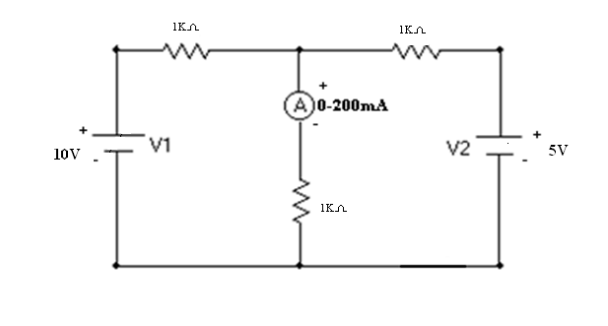
Fig 1
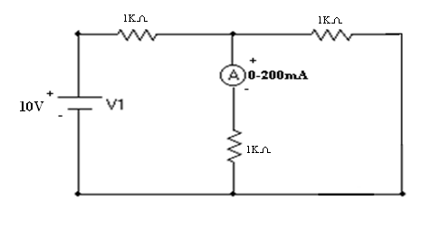
Fig 2
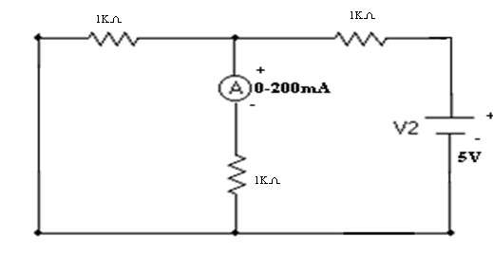
Fig 3
Circuit Diagrams of Reciprocity Theorem:
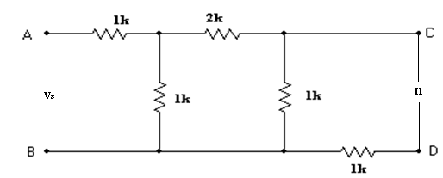
Fig.4
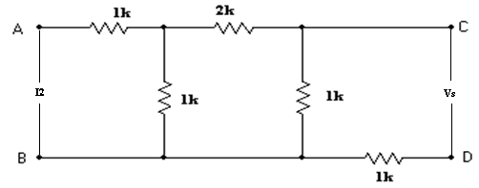
Fig.5
Procedure:

Superposition Theorem:

- The circuit is connected as shown in fig (1).

- Both the voltages V₁ and V₂ applied and the current through load resistor is noted as I_{X}.

- Supply voltage V₂ is replaced with short circuit and V₁ is applied as shown in fig (2) and the current through load resistor is noted down as I_{Y.}

- Supply voltage V₁ is replaced with short circuit and V₂ applied as shown in fig (3) and the current through load resistor is noted down as I_{Z.}

- It can be verified that I_{X} = I_{Y} + I_{Z} theoretically and practically which proves Superposition theorem.

Reciprocity Theorem:

- The circuit is connected as shown in fig (4).

- The ammeter reading is noted down as I₁.

  - Now the source and ammeter are interchanged as in fig

- The ammeter reading is noted down as I_{2.}.

- It can be veried that Vs/ I₁ = Vs/ I₂ theoretically and practically which proves Reciprocity theorem.

Super position theorem application:
- It is useful for electrical calculation of the circuits.
- Also used in transmission line drive calculation.
- Also to determine how long it will take a digital signal to go down a bus or a backplane
- This theorem interesting way to simplify circuit diagram allowing to search partial solution in the selected zone to be analyzed.
- It is used to transmission lines.

Observations:

Superposition Theorem

When both the sources are acting: fig (1)

Theoretical Practical
VS1(V) VS2(V)
I_{X}(A) I_{X}(A)

When V₁ source alone is acting: fig (2)

Theoretical Practical
VS1(V) VS2(V)
I_{y}(A) I_{y}(A)

When V₂ source alone is acting: fig (3)

VS1(V) | VS2(V) | I_{Z}(A) | I_{Z}(A)

Reciprocity Theorem:

Before interchanging the sources: fig (1)

 | Theoretical |  | values | Practical |  | values
Vs(V)
Vs(V) | I₁(A) |  | Vs/ I₁(Ω) | I₁(A) |  | Vs/ I₁(Ω)

After interchanging the sources: fig (2)

 | Theoretical |  | values | Practical |  | values
Vs(V)
Vs(V) | I₂(A) |  | Vs/ I₂(Ω) | I₂(A) |  | Vs/ I₂(Ω)

Precautions:

- Making loose connections are to be avoided.

- Readings should be taken carefully without parallax error.

Result:

Applications:
nonlinear network analysis, circuit theory, forbidden zone, linear circuits, mathematical fundamentals, nonlinear circuits, nonlinear resistive circuits, superposition theorem,Capacitance,Circuit analysis, Circuit theory, Computer science, Educational institutions, Linear circuits, Nonlinear circuits, Nonlinear equations,Resistors,Voltage,resistive circuits.

Viva Questions:

- Statement of superposition theorem
- What is the statement of Superposition theorem?
- How you will calculate the total resistance?
- State the super position theorem?
- What is meant by network?
- What is meant by bilinear network?
- Applications of superposition theorem?
- Can the theorem work for a circuit that has current sources and voltage sources mixed together?
- What is the practical application of a circuit that has multiple voltage sources?
- What is done to voltage sources while applying superposition theorem?
- What is done to current sources while applying superposition theorem?
- What is bilateral circuit?
- Why do we replace current source with a open circuit for calculating rth .
- Why do we replace voltage source with a short circuit for calculating rth .
- What do you mean by load?
- Which quantity is same in series circuit?
- Which quantity is same in parallel circuit?
- What do you mean by resistance of a conductor?
- What do you mean by ideal voltage source?
- What do you mean by ideal current source?
- What do you mean by practical voltage source?
- What do you mean by practical current source?
- What do you mean by positive temperature coefficient of resistance?
- What do you mean by negative temperature coefficient of resistance?
- What do you mean by zero temperature coefficient of resistance?
- Which colour wire is the positive wire of millimetre?
- Which colour wire is the negative wire of the millimetre?
- When the digital millimetre read voltage with negative sign, at that time the point at which red probe you have connected is at __________ potential?
- What does it mean when the meter read voltage or current with negative sign?
- The resistance of a conductor___________ if we increase the cross-sectional area ofa conductor?
- The resistance of a conductor___________ if we increase the length of a conductor?
- If the value of voltage ios in volts and current is in milli amperes then value of resistance is in__________?
- Why do we connect ammeter in series?
- Why do we connect voltmeter in parallel?
- What do you mean by resistance?
- What do you mean by impedance?
- State Kirchhoff’s voltage law?
- State Kirchhoff’s current law?
- State ohm’s law?
- Which law is required for applying Kirchhoff’s voltage law to a closed path if we know only esistances and current flowing in that path?
- Kirchhoff voltage law applicable to loop containing open in it
- How can you find out voltage rise or voltage drop or positive and negative sign using millimetre?
- How can you find out direction of current using millimetre in resistive load bank resistor are connected in series or parallel?
- If voltage rise is taken as positive then voltage drop is taken as________?
- If incoming current is taken as negative then outgoing current is taken as____________?
- How do you perform superposition theorem?
- Is superposition theorem applicable to a.c circuits?
- Name the material used or equipments required for performing superposition theorem experiment.
- In superposition theorem when deactivate voltage source why we replace it with a short circuit?
- In superposition theorem when deactivate current source why we replace it with a open circuit?
- Superposition theorem is applicable to circuit containing any number of linear independent sources?

EXERCISE PROBLEMS

- Find the current I in the circuit shown in figure using superposition theorem
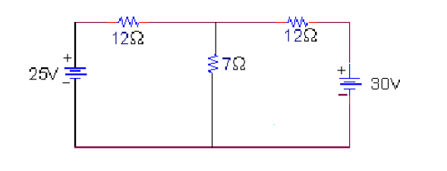

- A 6v battery having an internal resistance of 0.85Ω is connected to a load resistance R_{L}=3Ω. Determine the total power supplied to the load,

- A 6v battery having an internal resistance of 0.75Ω is connected to a load resistance R_{L}=4Ω. Determine the power dissipated and lost within the voltage source,

- A 8v battery having an internal resistance of 0.45Ω is connected to a load resistance R_{L}=7Ω. Determine the terminal voltage.

- A 6v battery having an internal resistance of 0.35Ω is connected to a load resistance R_{L}=8Ω. Determine the power supplied to the circuit when the voltage source is replaced by an ideal source with the same magnitude of source voltage.

- The voltage at the terminals of a particular power supply on no load is 12.5v.when a 5w load is attached, the voltage drops to 12v. Determine Vs&Rs for this practical source.

- The voltage at the terminals of a particular power supply on no load is 12.5v.when a 5w load is attached, the voltage drops to 12v. What would be the terminal voltage of the source when a 10Ω load resistor is connected?

- The voltage at the terminals of a particular power supply on no load is 12.5v.when a 5w load is attached, the voltage drops to 12v. How much current could be drawn from this power supply under short circuit conditions?

- An incandescent light bulb rated at 100w dissipates 100w as heat and light when connected across a 230v ideal voltage source. If four such bulbs are connected in series across the same source, determine the power each bulb will dissipate.

- Two resistances, each of 10Ω and 20Ω are connected in parallel across a dc voltage source. the current through the 10Ω resistance will be ?

- I have always viewed voltage sources as a battery of 1.5 Volt cells. These cells supply 1.5V (approx.) at whatever current is drawn, until they're dead. I find it difficult to conceptualise current sources, though. Is there a real-world current source that I can use to conceptualise such things?

- A battery of 1.5V cells, in my experience, is used to provide currents at about 1 to 100 milliamps. What kind of voltages should one expect from a current source?
- A 6v battery having an internal resistance of 0.45Ω is connected to a load resistance R_{L}=6Ω. Determine the terminal voltage.

- A 8v battery having an internal resistance of 0.35Ω is connected to a load resistance R_{L}=8Ω. Determine the power supplied to the circuit when the voltage source is replaced by an ideal source with the same magnitude of source voltage.

- The voltage at the terminals of a particular power supply on no load is 12.5v.when a 5w load is attached, the voltage drops to 15v. Determine Vs & Rs for this practical source.

- The voltage at the terminals of a particular power supply on no load is 12.5v.when a 5w load is attached, the voltage drops to 15v. What would be the terminal voltage of the source when a 12Ω load resistor is connected?

- The voltage at the terminals of a particular power supply on no load is 12.5v.when a 5w load is attached, the voltage drops to 12v. How much current could be drawn from this power supply under short circuit conditions?

- An incandescent light bulb rated at 200w dissipates 200w as heat and light when connected across a 230v ideal voltage source. If four such bulbs are connected in series across the same source, determine the power each bulb will dissipate.

- Two resistances, each of 20Ω and 40Ω are connected in parallel across a dc voltage source. the current through the 20Ω resistance will be ?

- A 6v battery having an internal resistance of 0.45Ω is connected to a load resistance R_{L}=3Ω. Determine the terminal voltage.

Expt. No.7
Maximum power transfer theorem

Aim: To verify maximum power transfer theorem on DC with Resistive load theoretically and practically.

Apparatus :

S.No | Name of the equipment | Range | Type | Quantity
1. | Ammeter | (0-200)mAmp | Digital | 1
2. | Voltmeter | (0-20)V | Digital | 1
3. | DC Power Supply | (0-30)V | Dual | 1
4. | Multimeter |  | Digital | 2
5. | Double Pole Double Throw Switch |  |  | 1
6. | Connecting wires |  |  | as per need

Theory:

Theorem Statement

It states that the maximum power is transferred from the source to the load, when the load resistance is equal to the source resistance.

Theoretical Calculations:

Formulae required:

Theoretical I_{L} = | ^{V}th
Theoretical I_{L} = | R_{L} +R _{th}

Circuit Diagrams:

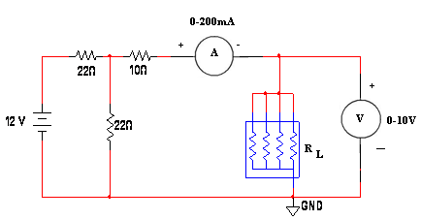

Model Graph:

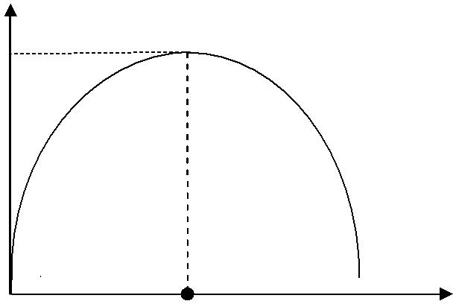
P_{L}
P_{m}

R_{L} corresponding to P_{m} R_{L}(Ω)

Procedure:

- Connections are made as shown in fig (1).

- R_{L} is varied in steps and the reading of ammeter I_{L} is noted down in each step.

- The circuit is connected as shown in fig (2) and the effective resistance R_{th} is measured with the help of digital multimeter.

- Power delivered to load P_{L} is calculated in each step.

- A graph is drawn between P_{L} Vs R_{L} and R_{L} corresponding to maximum power is found from it.

It can be verified that R_{L} corresponding to maximum power from the graph is equal to the R_{th} (which is nothing but source resistance R_{S}) which proves the maximum power transfer theorem.

Tabular column:
 | S.No | R_{L}(Ω) |  | Theoretical values |  |  |  |  | Practical values
 |  |  | I = | ^{V}th |  | (A) |  | P_{L}= I_{L}²R_{L}(watts) | I_{L}(A) | P_{L}= I_{L}²R_{L} (watts)
 |  |  | I = | R + R |  |  |  | P_{L}= I_{L}²R_{L}(watts) | I_{L}(A) | P_{L}= I_{L}²R_{L} (watts)
 |  |  | L
 |  |  |  | L | th

Model Calculations:

Precautions:

- Making loose connections are to be avoided.

- Readings should be taken carefully without parallax error.

Result:

Applications:
1. Public address system, the circuit is adjusted for maximum power transfer by making load resistance (speaker) equal to the source resistance (amplifier). When source and load have the same resistance, they are said to be matched.
2. In car engines, the power delivered to the starter motor of the car will depend upon the effective resistance of the motor and the internal resistance of the battery. If the two resistances are equal, maximum power will be transferred to the motor to turn to the engine.

Viva Questions:
- Statement of maximum power transfer theorem?

- When the maximum power transfer theorem?

- What is meant by power? Mention its unit?

- What is meant by Energy?

- What are the applications?

- Mention the application of maximum power transform theorem?

- What is meant by resistance matching?

- Give the interconnection for series network?

- What is the value of power factor?
- The rate at which work is being done ia an electrical circuit is called electrical power?
- Give the expression for maximum power?
- What is the condition for maximum power?
- Give the 3 different equations of power?
- What is the unit for power?
- What is the efficince during maximum power transfer?
- Define unilateral circuit?
17. Explain in breif how to thevenize the given circuit is thevenin’s theorem applicable to a.c circuits?

18. Name the material used or equipments required for performing thevenin’s theoremexperiment?4)
19.How do we measure rth practically?

20. How do we measure vth practically?

21. How do we calculate rth theoretically?

22. How do we calculate vth theoretically?

23. What do you mean by rth of a circuit?

24. How do you perform superposition theorem?

25.Is superposition theorem applicable to a.c circuits?

26. How do you perform maximum power transfer theorem?

27. Is maximum power transfer theorem applicable to a.c circuits?

28. Name the material used or equipments required for performing maximum power transfer theorem experiment?

29. Under what condition maximum power is delivered to the load resistance in acircuit containing only resistances?

30. Name any applications of maximum power transfer theorem?

31. State maximum power transfer theorem?transformers:1)

32. What are the applications of tranformer?

33. Transformer is a constant power device, true or false?

34. What do you mean by voltage regulation of a transformer?

35. Which are two windings in a transformer as far as voltages are concerned?

36. What do you mean by voltage transformation ratio of single phase transformer?

37. What do you mean by current ratio of single phase transformer?

38. What do you mean by turns ratio of single phase transformer
39. Which quantity is same in series circuit?
40. Which quantity is same in parallel circuit?
41. What do you mean by resistance of a conductor?
42. What do you mean by ideal voltage source?
43. What do you mean by ideal current source?
44. What do you mean by practical voltage source?
45. What do you mean by practical current source?
46. What do you mean by positive temperature coefficient of resistance?
47. What do you mean by negative temperature coefficient of resistance?
48. What do you mean by zero temperature coefficient of resistance?
49. What are the applications of maximum power
50. Define power

EXERCISE PROBLEMS

- Two resistances of 6Ω and 10Ω are connected in parallel. The parallel combination is connected in series with a 2Ω resistance and this series parallel combination is connected is connected across a dc source of 200v.Determine the current supplied by the source.

- Two resistances of 7Ω and 15Ω are connected in parallel. The parallel combination is connected in series with a 2Ω resistance and this series parallel combination is connected is connected across a dc source of 50v.How much current supplied by the source.

- An incandescent light bulb rated at 50w dissipates 20w as heat and light when connected across a 230v ideal voltage source. If six such bulbs are connected in series across the same source. Determine the power each bulb will dissipate.

- The voltage at the terminals of a particular power supply on no load is 15.5v.when a 7w load is attached, the voltage drops to 10v.How much current could be drawn from this power supply under short circuit conditions?

- Three resistances of 5Ω each are connected in delta. What is the value of resistances in the equivalent star?

- Two resistances, each of 15Ω and 10Ω are connected in parallel across a dc voltage source. The current through the 20Ω resistance will be?

- A 10v battery having an internal resistance of 2Ω is connected to a load resistance R_{L}=10Ω. Determine the terminal voltage.

- Two resistors each of 6Ω & 8Ω are connected in parallel and the parallel combination is connected in series with a 4Ω resistor. If this circuit is connected across a 50V supply, find the total current drawn.

- The voltage at the terminals of a particular power supply on no load is 15v.when a 10w load is attached, the voltage drops to 10v. Determine Vs & Rs for this practical source.

- Two batteries A& B having emf”s 15V and 20V resp and internal resistances of 9Ω and 7 Ω resp, are connected in parallel across 15 Ω resistor calculate the current in each of the battery applying KVL

- Two resistances of 8Ω and 12Ω are connected in parallel. The parallel combination is connected in series with a 4Ω resistance and this series parallel combination is connected is connected across a dc source of 200v.Determine the current supplied by the source.

- Two resistances of 8Ω and 15Ω are connected in parallel. The parallel combination is connected in series with a 4Ω resistance and this series parallel combination is connected is connected across a dc source of 50v.How much current supplied by the source.

- An incandescent light bulb rated at 50w dissipates 30w as heat and light when connected across a 230v ideal voltage source. If six such bulbs are connected in series across the same source. Determine the power each bulb will dissipate.

- The voltage at the terminals of a particular power supply on no load is 15.5v.when a 7w load is attached, the voltage drops to 20v.How much current could be drawn from this power supply under short circuit conditions?

- Three resistances of 6Ω each are connected in delta. What is the value of resistances in the equivalent star?

- Two resistances, each of 15Ω and 10Ω are connected in parallel across a dc voltage source. The current through the 30Ω resistance will be?

- A 10v battery having an internal resistance of 6Ω is connected to a load resistance R_{L}=20Ω. Determine the terminal voltage.

- Two resistors each of 4Ω & 6Ω are connected in parallel and the parallel combination is connected in series with a 6Ω resistor. If this circuit is connected across a 50V supply, find the total current drawn.

- The voltage at the terminals of a particular power supply on no load is 15v.when a 10w load is attached, the voltage drops to 10v. Determine Vs & Rs for this practical source.

- Two batteries A& B having emf”s 15V and 20V resp and internal resistances of 9Ω and 7 Ω resp, are connected in parallel across 15 Ω resistor calculate the current in each of the battery applying KVL

Expt. No.8
Experimental verification of Thevenin’s & Norton’s theorems

Aim: To verify Thevenin’s and Norton’s theorems theoretically and practically.

Apparatus:

S.No | Name of the equipment | Range | Type | Quantity
1. | Ammeter | (0-200)mAmp | Digital | 1
2. | Voltmeter | (0-20)V | Digital | 1
3. | DC Power Supply | (0-30)V | Dual | 1
4. | Digital Multimeter | ------- | Digital | 2
5. | Connecting wires | ------- | ----- | as per need

Theory:

Statement of Thevenin’s Theorem:

Any two terminal linear bilateral network containing of energy sources and impedances can be replaced with an equivalent circuit consisting of voltage source V_{th} in series with an impedance, Z_{th.}, where V_{th} is the open circuit voltage between the load terminals and Z_{th} is the equivalent impedance measured between the two terminals with all the energy sources replaced by their internal impedances.

Statement of Norton’s Theorem:

Any two terminal linear bilateral network containing of energy sources and impedances can be replaced with an equivalent circuit consisting of a Current source I_{N} in parallel with an impedance, Z_{N.}, where I_{N} is the short circuit current across the load terminals and Z_{N} is the equivalent impedance measured between the two terminals with all the energy sources replaced by their internal impedances.

Circuit Diagrams:

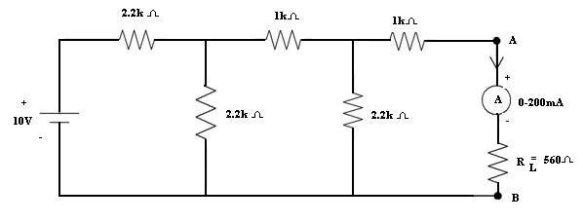
Fig-1
V_{th} :
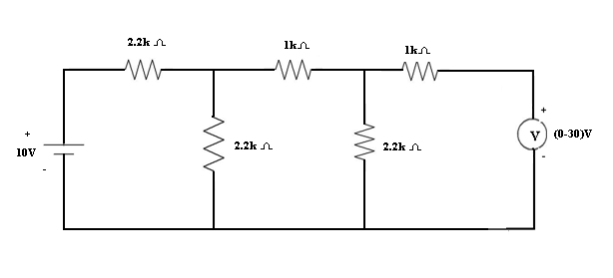

Fig-2

I_{l} :

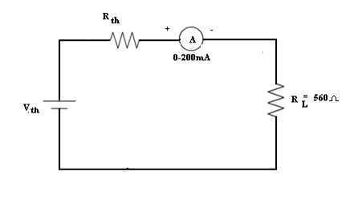
Fig-3

Procedure:

- Connections are made as per the circuit shown in fig (1).

- DC voltage is applied to the circuit and the current I_{L} flowing through the load is noted down.

- Circuit is connected as shown in fig (2). DC voltage is applied the reading of Ammeter is noted down as I_{N}.

- Circuit is connected as shown in fig (3). DC voltage is applied the reading of Voltmeter is noted down as V_{th}.
- The circuit is connected as shown in fig (4) and the effective resistance R_{th} / R_{N} is measured with the help of a multimeter.
- Thevenin’s equivalent circuit is connected as shown in fig (5) and the ammeter reading is noted down as I_{L}¹ .

- Thevenin’s theorem can be verified by checking that the currents I_{L} and I_{L}¹ are equal.

- Norton’s equivalent circuit is connected as shown in fig (6) and the ammeter reading is noted down as I_{L}¹ .

- Norton’s theorem can be verified by checking that the currents I_{L} and I_{L}¹ are equal.

Theoretical Calculations:

Observations:

Thevenin’s Theorem:

 |  | Theoretical values |  |  |  |  |  | Practical values
Vs(V)
Vs(V) | I_{L} | (A) | Vth(V) | Rth(Ω) |  | I_{L} ¹(A) | I_{L}(A) | Vth(V) | Rth(Ω) | I_{L}¹(A)

Norton’s Theorem:

 |  | Theoretical values |  |  |  |  |  | Practical values
Vs(V)
Vs(V) | I_{L}(A) |  | I_{N}(A) | R_{N}(Ω) |  | I_{L} ¹(A) | I_{L}(A) | I_{N}(A) | R_{N}(Ω) | I_{L}¹(A)

Precautions:

- Making loose connections are to be avoided.

- Readings should be taken carefully without parallax error

Result:

Applications:

Thevenin's & Norton's Theorem are used where the load can be varied .
So basically these methods reduce the big linear circuit into 1 source & 1 resistor (or impedance in AC). Later we can put any kind of load & measure the variations of current & voltages across the load.
The load can be a Fan, bulb, etc. So you can determine which component will be suitable to use.

Viva Questions:
- What is the statement of Thevenins theorem?
- How you will calculate the Thevenins resistance?
- Why Thevenins resister is connected in series with load resistance?
- What is the aim of the Thevenins theorem?
- What is the statement of Norton’s theorem?
- How you will calculate the Norton’s resistance?
- How you will calculate the Norton’s current?
- Why Norton’s resister is connected in parallel with load resistance?
- What is the aim of the Norton’s theorem?
- How to calculate Vth?
- How to calculate Rth?
- Define unilateral circuit?
13. Explain in breif how to thevenize the given circuit is thevenin’s theorem applicable to a.c circuits?

14. Name the material used or equipments required for performing thevenin’s theoremexperiment?4)
15.How do we measure rth practically?

16.. How do we measure vth practically?

17. How do we calculate rth theoretically?

18. How do we calculate vth theoretically?

19. What do you mean by rth of a circuit?

20. How do you perform superposition theorem?

21.Is superposition theorem applicable to a.c circuits?

22. How do you perform maximum power transfer theorem?

23. Is maximum power transfer theorem applicable to a.c circuits?

24. Name the material used or equipments required for performing maximum power transfer theorem experiment?

25. Under what condition maximum power is delivered to the load resistance in acircuit containing only resistances?

30. Name any applications of maximum power transfer theorem?

31. State maximum power transfer theorem?transformers:1)

32. What are the applications of tranformer?

33. Transformer is a constant power device, true or false?

34. What do you mean by voltage regulation of a transformer?

35. Which are two windings in a transformer as far as voltages are concerned?

36. What do you mean by voltage transformation ratio of single phase transformer?

37. What do you mean by current ratio of single phase transformer?

38. What do you mean by turns ratio of single phase transformer
39. Which quantity is same in series circuit?
40. Which quantity is same in parallel circuit?
41. What do you mean by resistance of a conductor?
42. What do you mean by ideal voltage source?
43. What do you mean by ideal current source?
44. What do you mean by practical voltage source?
45. What do you mean by practical current source?
46. What do you mean by positive temperature coefficient of resistance?
47. What do you mean by negative temperature coefficient of resistance?
48. What do you mean by zero temperature coefficient of resistance?
49. What are the applications of maximum power
50. Define power

EXERCISE PROBLEMS

1. Two resistances of 5Ω and 20Ω are connected in parallel. The parallel combination is connected in series with a 1Ω resistance and this series parallel combination is connected is connected across a dc source of 100v.Determine the current supplied by the source.

2. Three resistances of 3Ω each are connected in delta. What is the value of resistances in the equivalent star?

3. The voltage at the terminals of a particular power supply on no load is 11.5v.when a 5w load is attached, the voltage drops to 8v.Determine Visors for this practical source.

4. The voltage at the terminals of a particular power supply on no load is 11.5v.when a 5w load is attached, the voltage drops to 8v.What would be the terminal voltage of the source when a 10Ω load resistor is connected?

5. The voltage at the terminals of a particular power supply on no load is 11.5v.when a 5w load is attached, the voltage drops to 8v.How much current could be drawn from this power supply under short circuit conditions?

6. An incandescent light bulb rated at 70w dissipates 50w as heat and light when connected across a 230v ideal voltage source. If four such bulbs are connected in series across the same source. Determine the power each bulb will dissipate.

7. Two resistances of 5Ω and 20Ω are connected in parallel. The parallel combination is connected in series with a 1Ω resistance and this series parallel combination is connected is connected across a dc source of 100v.How much current supplied by the source.

8. The equivalent circuit of a network represented by thevenin’s equivalent with V_{th}=12v and R_{th}=8Ω is connected to a load resistance R_{L}. If the conditions for maximum power transfer exits.
Determine the value of R_{L},

9. The equivalent circuit of a network represented by thevenin’s equivalent with V_{th}=12v and R_{th}=8Ω is connected to a load resistance R_{L}. If the conditions for maximum power transfer exits.
Determine the Power developed in R_{L},

10. The equivalent circuit of a network represented by thevenin’s equivalent with V_{th}=12v and R_{th}=8Ω is connected to a load resistance R_{L}. If the conditions for maximum power transfer exits. Determine the Efficiency of the circuit.

11.Two resistances of 6Ω and 10Ω are connected in parallel. The parallel combination is connected in series with a 2Ω resistance and this series parallel combination is connected is connected across a dc source of 100v.Determine the current supplied by the source.

12. Three resistances of 6Ω each are connected in delta. What is the value of resistances in the equivalent star?

13. The voltage at the terminals of a particular power supply on no load is 11.5v.when a 5w load is attached, the voltage drops to 10v.Determine Visors for this practical source.

14. The voltage at the terminals of a particular power supply on no load is 11.5v.when a 5w load is attached, the voltage drops to 10v.What would be the terminal voltage of the source when a 10Ω load resistor is connected?

15. The voltage at the terminals of a particular power supply on no load is 1.5v.when a 5w load is attached, the voltage drops to 8v.How much current could be drawn from this power supply under short circuit conditions?

16. An incandescent light bulb rated at 40w dissipates 30w as heat and light when connected across a 230v ideal voltage source. If four such bulbs are connected in series across the same source. Determine the power each bulb will dissipate.

17. Two resistances of 15Ω and 20Ω are connected in parallel. The parallel combination is connected in series with a 1Ω resistance and this series parallel combination is connected is connected across a dc source of 100v.How much current supplied by the source.

18. The equivalent circuit of a network represented by thevenin’s equivalent with V_{th}=15v and R_{th}=2Ω is connected to a load resistance R_{L}. If the conditions for maximum power transfer exits.
Determine the value of R_{L},

19. The equivalent circuit of a network represented by thevenin’s equivalent with V_{th}=10v and R_{th}=5Ω is connected to a load resistance R_{L}. If the conditions for maximum power transfer exits.
Determine the Power developed in R_{L},

20. The equivalent circuit of a network represented by thevenin’s equivalent with V_{th}=15v and R_{th}=6Ω is connected to a load resistance R_{L}. If the conditions for maximum power transfer exits. Determine the Efficiency of the circuit.

PART-B
Expt. No.1

Magnetization Characteristics of DC Shunt Generator

Aim: To conduct an experiment on a D.C Shunt Generator and draw the magnetization
characteristics (Open Circuit Characteristics or OCC) and to determine the Critical Field Resistance (R_{C}) and Critical Speed (N_{C}).

Apparatus:

S. No | Apparatus | Type | Range | Qty
1 | Voltmeter | M.C | (0-300)V | 1
2 | Ammeter | M.C | (0-2)A | 1
3 | Rheostats | Wire | 370Ω/1.7A | 2
 |  | wound
4 | Tachometer | Digital | 0-9999 rpm | 1
5 | Connecting wires | -------- | ------------ | As required

Name plate details:

Theory:

Open circuit characteristics or magnetization curve is the graph between the generated emf (E_{g}) and field current (I_{f}) of a dc shunt generator. For field current is equal to zero there will be residual voltage of 10 to 12V because of the residual magnetism present in the machine .If this is absent then the machine can not build up voltage. To obtain residual magnetism the machine is separately excited by a dc source. We can get critical field resistance (R_{C}) and critical speed (N_{C}) from OCC.
Critical field resistance: It is the value of field rresistance above which the machine cannot build up emf.

Critical speed: It is the speed below which the machine cannot build up emf.
CIRCUIT DIAGRAM:

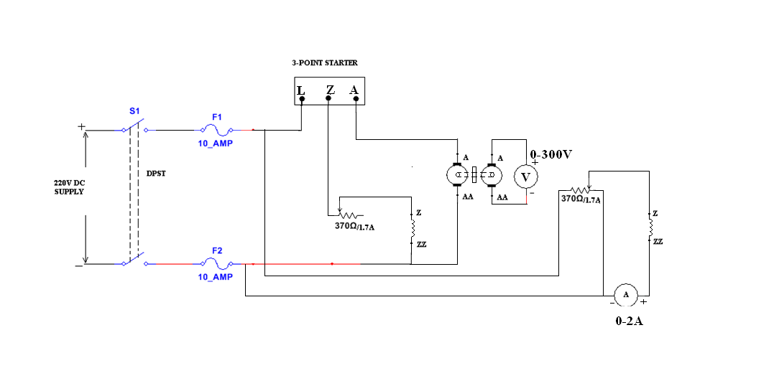

Model Graph:
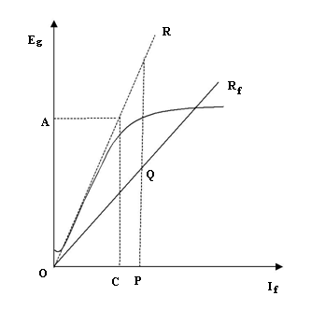

Procedure:

- Connections are made as per the circuit diagram.

- Motor is started with the help of Three Point starter and brought to its rated speed by varying the field rheostat.

- The Eg for I_{f} =0 is noted and the DPST switch on the DC Exciter side is closed.

- The DC Exciter is varied in steps and the values of Field current (I_{f}) and corresponding generated voltage (Eg) are noted down in each step, in both ascending and descending orders.

- Average Eg is calculated from ascending and descending orders.

- A graph is drawn between E_{g} & I_{f}. From the graph (OCC), Critical field resistance (R_{C}) and Critical (N_{C}) speed are calculated.

Calculations:

From the graph:

Critical field Resistance, R _{C} = OA
OC
Critical Speed, N_{C} = PQ × N _{rated}
PR

Tabular column:

S.No | Field current | Generated Voltage (Eg) |  | Average
 | I_{f} (A) |  |  | Eg (V)
 |  | Ascending | Descending
 |  | order | order

Precautions:

- Loose connections should be avoided.

- Readings are taken without parallax error.

Result:

Applications:

Applications of Shunt Wound DC Generators

1. They are used for general lighting.
2. They are used to charge battery because they can be made to give constant output voltage.
3. They are used for giving the excitation to the alternators.
4. They are also used for small power supply.

Applications of Series Wound DC Generators
These types of generators are restricted for the use of power supply because of their increasing terminal voltage characteristic with the increase in load current from no load to full load. We can clearly see this characteristic from the characteristic curve of series wound generator. They give constant current in the dropping portion of the characteristic curve. For this property they can be used as constant current source and employed for various applications.
- They are used for supplying field excitation current in DC locomotives for regenerative braking.
- These types of generators are used as boosters to compensate the voltage drop in the feeder in various types of distribution systems such as railway service.
- In series arc lightening this type of generators are mainly used.

Viva Questions:
- What are the merits of separate excitation?

- If the generator does not build up voltage, what are the possible causes?

- How are two generators operated in parallel?

- What are the different methods of excitation?

- What is the function of a DC Generator?

- Define critical resistance?

- What is ment by residual magnetism?

8. What is the Basic Principle in dc generator?

9. In DC Machine which Induced emf is suitable?

10. The direction of induced emf and hence current in a conductor can be determined by?

11. Mechanical Energy Converted to Electrical energy is called as?

12. Write the EMF equation for D.C. Generator?

EXERCISE PROBLEMS

- The open circuit characteristics of a DC shunt generator driven at rated speed is as follows
Field current | 0.5A | 1A | 1.5A | 2A
Induced voltage | 60V | 120V | 138V | 145V
If resistance of field circuit is adjusted to 53Ω calculate the critical Resistance.

- The open circuit characteristics of a DC shunt generator driven at rated speed is as follows
Field current | 0.05A | 0.5A | 1A | 1.5A
Induced voltage | 120V | 138V | 145V | 180V
If resistance of field circuit is adjusted to 100Ω calculate the critical Resistance.

- A 10KW, DC shunt generator driven at rated speed is as follows
Field current | 1.1A | 1.2A | 1.3A | 1.4A
Induced voltage | 20V | 38V | 45V | 80V
If resistance of field circuit is adjusted to 120Ω, calculate the critical speed at 1200rpm.
- A 4pole wave wound generator has 40 slots and 24 conductors per slot .the flux per pole is 10mwb.determine the induced emf in the armature if it is rotating at a speed of 700rpm.
- A 230v shunt generator takes 5A at no-load. The resistances of the armature and field circuit are 0.25Ώ and 115Ώ. If the motor is loaded so as to carry 40A.determine i) iron losses and frictional losses ii) efficiency
- A short shunt compound generator supplied 7.5kw at 230v the shunt field , series field and armature resistance are 100, 0.3, 0.4Ώ. Cal the induced emf and the load resistance.
- A dynamo has a rated armature current at 250A. What is the current path of the armature if the winding is lap or wave connected? The machine has 12 poles.
- An 8 pole 230V wave connected DC shunt motor delivers 10A and having armature and shunt field resistance are 0.6Ω and 30 Ω resp. Find the total losses when the stray losses are 50W.
- A 15KW, 220V DC shunt motor having constant losses and copper losses are 25W and 35W. Find the efficiency.When running on no load, a 220V shunt motor takes 10A armature resistance is 0.2Ω and field resistance is 300Ω find the output of the motor.
- The open circuit characteristics of a DC shunt generator driven at rated speed is as follows
Field current | 0.5A | 1A | 1.5A | 2A
Induced voltage | 60V | 120V | 138V | 145V
If resistance of field circuit is adjusted to 53Ω calculate the critical Resistance.

- The open circuit characteristics of a DC shunt generator driven at rated speed is as follows
Field current | 0.04A | 0.6A | 1.2A | 1.5A
Induced voltage | 110V | 130V | 140V | 150V
If resistance of field circuit is adjusted to 100Ω calculate the critical Resistance.

- A 10KW, DC shunt generator driven at rated speed is as follows
Field current | 1.5A | 1.6A | 1.2A | 1.5A
Induced voltage | 30V | 36V | 50V | 80V
If resistance of field circuit is adjusted to 120Ω, calculate the critical speed at 1500rpm.
- A 6pole wave wound generator has 60 slots and 24 conductors per slot .the flux per pole is 20mwb.determine the induced emf in the armature if it is rotating at a speed of 600rpm.
- A 220v shunt generator takes 5A at no-load. The resistances of the armature and field circuit are 0.25Ώ and 115Ώ. If the motor is loaded so as to carry 40A.determine i) iron losses and frictional losses ii) efficiency
- A short shunt compound generator supplied 7.5kw at 230v the shunt field , series field and armature resistance are 200, 0.3, 0.4Ώ. Cal the induced emf and the load resistance.
- A dynamo has a rated armature current at 250A. What is the current path of the armature if the winding is lap or wave connected? The machine has 12 poles.
- An 6 pole 220V wave connected DC shunt motor delivers 10A and having armature and shunt field resistance are 0.6Ω and 30 Ω resp. Find the total losses when the stray losses are 50W.
- A 12KW, 220V DC shunt motor having constant losses and copper losses are 25W and 34W. Find the efficiency.When running on no load, a 220V shunt motor takes 10A armature resistance is 0.2Ω and field resistance is 300Ω find the output of the motor.
- A 6pole wave wound generator has 40 slots and 24 conductors per slot .the flux per pole is 10mwb.determine the induced emf in the armature if it is rotating at a speed of 600rpm.
- A 210v shunt generator takes 5A at no-load. The resistances of the armature and field circuit are 0.25Ώ and 115Ώ. If the motor is loaded so as to carry 40A.determine i) iron losses and frictional losses ii) efficiency
Expt. No.2
Swinburne’s test

Aim: To perform no load test on a DC shunt motor and to predetermine the efficiencies of the machine acting both as a motor and as a generator.

Equipment:

S.No | Apparatus | Type | Range | Qty
1 | Voltmeter | MC | (0-300)V | 1
2 | Ammeter | MC | (0-20)A | 1
3 | Ammeter | MC | (0-2)A | 1
4 | Rheostats | Wire wound | 370Ω/1.7A | 1
5 | Connecting wires | -------- | ------------ | As required

Name plate details:

Theory:
Swinburne’s test or no load test is indirect method of testing the dc motors in which the flux remains practically constant .In this test, actually without loading the motor the motor losses and hence the efficiency at different loads can be predetermined. In this method, the motor is run on no load at its rated voltage. At the starting, the motor is run at rated speed and the no-load armature current I_{a} is noted.
The power fed tpo the motor is V(I_{a} + I_{sh}).
The field copper loss is I_{sh}² R_{sh} and armature copper loss I_{a}² R_{a}.
The total copper losses are I_{sh}² R_{sh} + I_{a}² R_{a}.
The constant losses are W_{const} = V(I_{a} + I_{sh}).- I_{sh}² R_{sh} + I_{a}² R_{a}
These constant losses are remaining constant even it is loaded.
If the full load current is I_{L} , the armature current flowing through is I_{L}- I_{sh},
Full load copper losses are I_{sh}² R_{sh} + I_{a}² R_{a}
The constant losses are already known.
Hence the total losses are Constant losses + Full load copper losses.
The input to the motor if the machine is motor is V I_{L}
The output of the motor is input _ losses
The efficiency of the motor is the ratio output to the input.
The advantage of this test is the efficiency of the machine either motor or generator can be predetermined at any load without conducting the actual test. The disadvantage is that the constant losses are not really constant but varies from no-load to full load and the efficiency computed can reliable.

CIRCUIT DIAGRAM:

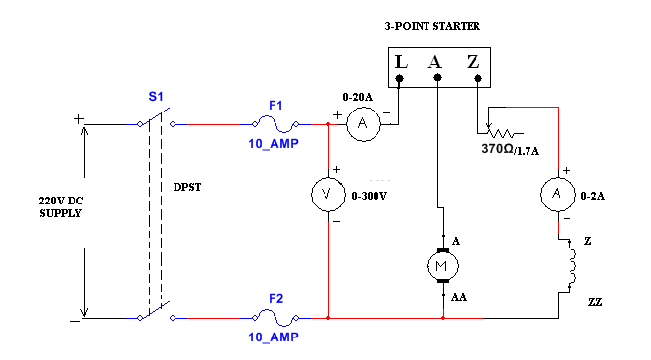
MODEL GRAPH:

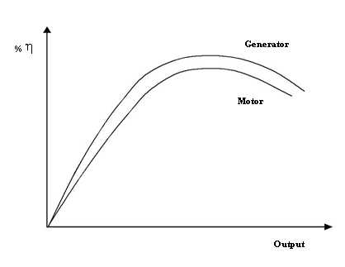

Procedure:

- Connections as made as per the circuit diagram.

- Field rheostat is kept in minimum position and the motor is started with the help of 3-Point starter, and is brought to rated speed by adjusting field rheostat.
- The readings of both ammeters and voltmeter are noted down.

- The efficiencies of the machine both as a motor and as a generator are calculated.

- Graphs are drawn between output Vs efficiency for the Machine acting as a generator and as a motor.

No-Load Test Observation table:
 | IL0 (A) |  | I_{f} (A) | V (v) | N (rpm)

Calculations:

From No-Load Test:

No - Load input = VI_{L0} =

No - Load Armature current = I_{L0} − I_{f} =

No - Load Armature Cu loss = I_{a0} ² R_{a} =

Constant loss, W_{C} = No - load input − No - load Armature Cu loss = VI_{L0} −I_{a0} ² R _{a} =

∴ W_{C} =

Model calculation:

To Predetermine the Efficiency as a Motor:

Let I_{L}=

Motor input = VI_{L} =

Total loss = W_{C} + I_{a} ²R_{a} = W_{C} +(I_{L} - I_{f} )² R_{a} =

Motor Output = Motor input - Total loss =

∴Efficiency, η = output/input×100

To Predetermine the Efficiency as a Generator:

Let I_{L}=

Generator Output = VI_{L} =

Total loss = W_{C} + I_{a} ² R _{a} = W_{C} + (I_{L} + I_{f} )² R _{a} =

Generator Input = Generator output +Total loss =

∴Efficiency, η = output/input×100

EFFICIENCY AS A MOTOR

SNo. | V  (v) | I_{L}  (A) | I_{f}  (A) | I_{a}=  I_{L}- I_{f}  (A) | I²R losses P_{cu}=  Ia² Ra  (watts) | Const.  losses  W const  (watts) | Total Losses  P_{cu}+ P_{con}  (watts) | Input  V I_{L}  (watts) | Output = input – total losses  (watts) | η = output /input  (%)

EFFICIENCY AS A GENERATOR:
SNo. | V  (v) | I_{L}  (A) | I_{f}  (A) | I_{a}=  I_{L}+ I_{f}  (A) | I²R losses P_{cu}=  Ia² Ra  (watts) | Const.  losses  W const  (watts) | Total Losses  P_{cu}+ P_{con}  (watts) | Output  V I_{L}  (watts) | Input = output + total losses  (watts) | η = output /input  (%)

Results:

Applications:
. The main advantages of the Swinburne’s test are as follows:-
- The power required to test a large machine is small. Thus, this method is an economical and convenient method of testing of DC machines.
- As the constant loss is known the efficiency can be predetermined at any load.
Disadvantages
Change in iron loss is not considered at full load from no load. Due to armature reaction flux is distorted at full load and, as a result, iron loss is increased.
- As the Swinburne’s test is performed at no load. Commutation on full load cannot be determined whether it is satisfactory or not and whether the temperature rise is within the specified limits or not.
Limitations
- Machines having a constant flux are only eligible for Swinburne’s test. For examples – shunt machines and level compound generators.
- Series machines cannot run on light loads, and the value of speed and flux varies greatly. Thus, the Swinburne’s Test are not applicable for series machines

Viva Questions:
- Compare the efficiency of Generator and Motor .Comment on the result.
- Can the Swinburne’s test be performed on a series motor?
- Why is it not possible to get higher speeds with armature voltage method?
- Can lower speeds be obtained by using field control method?
- What are the disadvantages of armature and field control method?
- What is the purpose of a fuse?
- Why the field rheostat should be kept in minimum position?

- Which of the following is the unit of Torque ?

- When the starting resistance of a D.C. motor is used generally?

- Armature Reaction is related to?

- Brushes are made up of?

- The function of the commutator?

- Which motor is suitable for Electric Traction?

- DC Motors in Starters are used to?

- Swinburne’s test is conducted on DC Shunt Machine at?

- Armature windings are made up of?

- Will the values deduced from the Swinburne’s method exactly coincide with the value realized by direct loading on the machine? Why?

- Why are the constant losses calculated by this method less than the actual losses?

- Can we conduct Swinburne’s test on dc series motor?

- What are the drawbacks of Swinburne’s test?

- Classify the different losses in dc machine?
- Applications of the DC Shunt motor
- Applications of the DC Series motor
- Applications of the DC Compoundt motor
- Why do we use starter for dc machine?
- Explain Different Methods Of Speed Control Of D.c Shunt Motors?
- Why Is The Starting Current High In A Dc Motor (or) Why Do We Use A Starter?
- Distinguish between back emf.
- Comparition between series shunt motor.
- Write the emf equation of dc generator
- What happens if DC supply is applied to the transformer?
- What is the application of equivalent circuit of a single phase transformer?
- What is synchronous speed?
- What is meant by torque? or Define torque?
- How can we reduce the eddy current loss in the electrical machine?
- In DC generators, the series field winding has low resistance while the shunt field winding has high resistance. Why?
- Why series motor cannot be started on no-load?

38.Which type of motor is used in trains, what is the rating of supply used?

39. What is the principle of operation of a d.c motor?

40. What is back e.m.f or counter e.m.f?

41. What is speed regulation?

42. Why series motor cannot be started on no-load?

43.Which type of motor is used in trains, what is the rating of supply used?

44. Explain different methods of speed control of d.c shunt motors?
45.What the need of 3-point starter
46.Draw the relation between speed and torque.
47. Draw the relation between speed and BHP.
48. Draw the relation between speed and output power.
49. Draw the relation between output and efficiency.
50. Draw the relation between speed and losses

EXERCISE PROBLEMS

- A 220V, DC shunt motor at no load takes a current of 2.5A. The resistance of the armature and shunt field is 0.8Ω and 200 Ω resp. Estimate the efficiency of the given shunt motor.
- When running on no load, a 220V shunt motor takes 5A armature resistance is 0.5Ω and field resistance is 200Ω find the output of the motor
- The no load test of a 44.76KW, 220V ,DC shunt motor gave the following data :
Input current: 13.25A
Field current: 2.55A
Armature resistance at 75ºC =0.032Ω and brush drop 2V.Estimate the efficiency.
- A 220V, DC shunt motor at no load takes a current of 2A. The resistance of the armature is 0.2Ω, when the field current is 1A Estimate the efficiency of the given shunt motor.
- A 4 pole, 10KW DC shunt motor delivers 5A and having armature and shunt field resistances are 0.5Ω and 100 Ω resp. Find the generated voltage of the motor, the supply voltage is 220V and brush drop is 1V per brush.
- The no load test of a 20KW, 220V ,DC shunt motor gave the following data: Input current is 10A ,Field current is 2A
Armature resistance is 0.032Ω and brush drop 2V.Estimate the efficiency.
- A 220V, DC shunt motor at no load takes a current of 2.5A. The resistance of the armature and shunt field is 0.8Ω and 200 Ω resp. Estimate the efficiency of the given shunt motor at constant losses are 10W.
- When running light load as a motor at full load speed, the line current was 10A the field current is 1A the supply voltage is 230V and armature resistance is 0.5Ω.Calculate the copper losses
- A 6 pole 230V wave connected DC shunt motor delivers 10A and having armature and shunt field resistance are 0.1Ω and 60 Ω resp. Find the total losses when the stray losses are 50W.
- A 10KW, 220V DC shunt motor having constant losses and copper losses are 50W and 25W. Find the efficiency
- A 220V, DC shunt motor at no load takes a current of 2.0A. The resistance of the armature and shunt field is 0.5Ω and 180 Ω resp. Estimate the efficiency of the given shunt motor.
- When running on no load, a 220V shunt motor takes 4A armature resistance is 0.7Ω and field resistance is 200Ω find the output of the motor
- The no load test of a 44KW, 220V ,DC shunt motor gave the following data :
Input current: 13.25A
Field current: 2.55A
Armature resistance at 75ºC =0.032Ω and brush drop 2V.Estimate the efficiency.
- A 220V, DC shunt motor at no load takes a current of 2.5A. The resistance of the armature is 0.5Ω, when the field current is 1A Estimate the efficiency of the given shunt motor.
- A 4 pole, 30KW DC shunt motor delivers 5A and having armature and shunt field resistances are 0.55Ω and 100 Ω resp. Find the generated voltage of the motor, the supply voltage is 220V and brush drop is 1V per brush.
- The no load test of a 20KW, 220V ,DC shunt motor gave the following data: Input current is 10A ,Field current is 2A
Armature resistance is 0.032Ω and brush drop 2V.Estimate the efficiency.
- A 220V, DC shunt motor at no load takes a current of 3.5A. The resistance of the armature and shunt field is 0.85Ω and 100 Ω resp. Estimate the efficiency of the given shunt motor at constant losses are 30W.
- When running light load as a motor at full load speed, the line current was 8A the field current is 1A the supply voltage is 230V and armature resistance is 0.5Ω.Calculate the copper losses
- A 6 pole 220V wave connected DC shunt motor delivers 10A and having armature and shunt field resistance are 0.1Ω and 80 Ω resp. Find the total losses when the stray losses are 50W.
- A 100KW, 220V DC shunt motor having constant losses and copper losses are 10W and 25W. Find the efficiency.

Expt. No.3

BRAKE TEST ON DC SHUNT MOTOR

Aim: To determine the efficiency of a DC shunt motor by conducting brake test.

Apparatus:
S. No | Apparatus | Type | Range | Quantity
1 | Voltmeter | MC | (0 – 300)V | 1 No
2 | Ammeter | MC | (0 – 20)A | 1 No
3 | Rheostat | Wire wound | 370Ω/1.7A | 1 No
4 | Ammeter | MC | (0 – 2)A | 1 No
5 | Tachometer | DIGITAL | 0-9999 rpm | 1 No
 | Connecting wires | -------- | ------------ | As required

Theory:
The precondition to be set for the load test on DC shunt motor is to run the motor at the rated voltage and the rated speed. For Small motors the efficiency can be found directly by a brake test. The loading arrangement done to the motor is that a brake drum is attached to the shaft of the motor and spring balances are connected through which the brake drum is tightened so that the shaft is loaded. This set is said to be called as applied mechanical load. The torque can be determined and speed is measured from which the power output can be calculated. The input to the motor is found by knowing the applied voltage and load current. Hence the efficiency can be known.
Let ‘S1’ and ‘S2’ are the spring balance readings.
The pull on the brake drum = 9.81 (S1-S2) Newton
Torque on the drum= T_{sh} = 9.81 (S1-S2) r Nw-m Where ‘r’ is the radius of the drum
Motor power output = T_{sh} * 2π N/60 watts; where N is the rpm of the motor
Let input voltage and current are V and I
Power input to the motor is V*I

The efficiency = η = output/ input

CIRCUIT DIAGRAM:
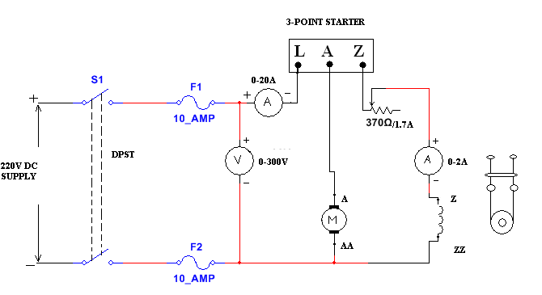

MODEL GRAPH:

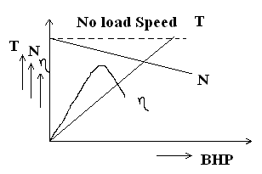

Procedure:

- Connections are made as shown in the circuit diagram.

- Field rheostat is kept in minimum position and the motor is started with the help of 3-Point starter, and is brought to rated speed by adjusting field rheostat.
- By varying the load in steps, readings of ammeters, voltmeter, tachometer, spring balances, are noted down.
- Performance curves are to be drawn after completing the calculations.

Precaution:
- Before starting the experiment pour some water into the brake drum and also while doing the experiment.
- Stay away from the brake drum when switching off the motor.

Tabular column:
S no. | V  (Volt) | I_{L}  (Amp) | N  (rpm) | S1  (Kg) | S2  (Kg) | W=S1-S2 (Kg) | T= 9.81 W r  (Nm) | Output=  2πNT/60  (watts) | Input=  VI_{L} (Watts) | η = output/  Input (%)

(“r” is the radius of the drum)
Result:

Applications:

Lathe Machines, Centrifugal Pumps, Fans, Blowers, Conveyors, Lifts, Weaving Machine, Spinning machines

Viva Questions:
- What are the methods for finding the efficiency?
- What are the basic requirements to conduct the load test?
- Compare the load characteristics for different types of DC motors.
- If two motors are required to drive a common load, how will they share the total load?
- What are the different types of a DC Motor?
- What is the purpose of a three point starter?
- When DC Generator fails to build up the voltage, what are the reasons?
- What is field flashing?
- Why do we use starter for dc machine?
- Factor that has to be considered while choosing the resistor?
- What are the different losses in dc machine?
- Drawbacks of Brake test?
- What happens if DC supply is applied to the transformer?
- What is the application of equivalent circuit of a single phase transformer?
- What is synchronous speed?
- What is meant by torque? or Define torque?
- How can we reduce the eddy current loss in the electrical machine?
- In DC generators, the series field winding has low resistance while the shunt field winding has high resistance. Why?
- Why series motor cannot be started on no-load?

20.Which type of motor is used in trains, what is the rating of supply used?

21. What is the principle of operation of a d.c motor?

22. What is back e.m.f or counter e.m.f?

23. What is speed regulation?

24. Why series motor cannot be started on no-load?

25. Which type of motor is used in trains, what is the rating of supply used?

26. Explain different methods of speed control of d.c shunt motors?

27. Explain different methods of speed control of d.c series motors?
28. Why is the starting current high in a DC motor (or) Why do we use a starter?

29. How can you reverse the direction of rotation of a D.C Motor?

30. Why the field of a D.C Shunt motor should not be open?

31. What will happen if the direction of current at the terminals of a D.C Motor is reversed?

32. What happens when a D.C motor is connected across an A.C supply?

33. Mention the methods for starting an induction motor?

34 What are the types of starters used for starting of D.C Motors?

35. What are the advantages of star-delta starter with induction motor?

36. What are the different tests conducted on D.C Machines?

37. Why is Swinburne’s test conducted?
38. Does the direction of rotation of d.c. shunt motor would get reversed if the armature current and
field current both are reversed?
39. If the rated speed of a d.c. shunt motor is1440 r.p.m, which method of speed control would you
suggested to obtain a speed of 1500 r.p.m?
40. Drawbacks of Brake test?
41. Classify the different losses in dc machine?
42. Applications of the DC Shunt motor
43. Applications of the DC Series motor
44. Applications of the DC Compoundt motor
45. Why do we use starter for dc machine?
46. Explain Different Methods Of Speed Control Of D.c Shunt Motors?
47. Why Is The Starting Current High In A Dc Motor (or) Why Do We Use A Starter?
48. Distinguish between back emf.
49. Comparition between series shunt motor.
50. Write the emf equation of dc generator

EXERCISE PROBLEMS

- In a brake test the effective load on the branch pulley was 38.1Kg, the effective diameter of the pulley 63.5cm and speed 12rps the motor took 49A at 220V. Calculate the output power
- The following readings are obtained when doing a load test on a DC shunt motor using a brake drum
Spring balance |  | Voltage | Speed | I_{L} | I_{F} | Diameter of the drum
S1 | S2
10Kg | 35Kg | 200V | 950rpm | 30A | 1A | 40cm
Calculate the efficiency.
- In a brake test, on a DC shunt motor the tension on the two sides of the brakes are 2.9Kg and 0.17Kg. Radius of the pulley was 7cm. Input current was 2A at 230V. The motor speed was 1500rpm find the torque.
- A 10 KW DC shunt motor has the effective load on the branch pulley was 18.1Kg, the effective diameter of the pulley 53.5cm and speed 1500rpm the motor took 50A at 220V. Calculate the efficiency.
- The following readings are obtained when doing a load test on a DC shunt motor using a brake drum :
Spring balance 5Kg and 3Kg Diameter of the drum 12cm
Line current 14A and applied voltage is 240V. Find output power and BHP.
- A 4 pole, 10KW DC shunt motor delivers 5A and having armature and shunt field resistances are 0.1Ω and 50Ω resp. Find the generated voltage of the motor, the supply voltage is 220V and brush drop is 1V per brush.
- In a given dc machine, if p=8, Z=400, N=300rpm and Ø=100mwb, calculate the generated emf when the winding is a) lap connected b) wave connected.
- The armature of dc machine has a armature resistance of 0.1Ω and is connected a supply of 230v. Calculate the generated emf when it is running as a) generator giving 80A b) motor taking 60A.
- A 8 pole lap wound dc generator has 960 conductors, a flux of 40mwb and is driven at 400rpm find induced emf.
- A 230v dc shunt motor takes 5A at no load and runs at 1000rpm. Calculate the speed when loaded and taking a current of 30A. The armature and field resistance are 0.4 and 230Ώ.
- In a brake test the effective load on the branch pulley was 38.1Kg, the effective diameter of the pulley 63.5cm and speed 15rps the motor took 50A at 230V. Calculate the output power
- A 4 pole lap wound dc generator has 960 conductors, a flux of 40mwb and is driven at 600rpm find induced emf.
- In a brake test, on a DC shunt motor the tension on the two sides of the brakes are 2.9Kg and 0.17Kg. Radius of the pulley was 9cm. Input current was 5A at 230V. The motor speed was 1500rpm find the torque.
- A 10 KW DC shunt motor has the effective load on the branch pulley was 18.1Kg, the effective diameter of the pulley 53.5cm and speed 1500rpm the motor took 50A at 220V. Calculate the efficiency.
- The following readings are obtained when doing a load test on a DC shunt motor using a brake drum :
Spring balance 6Kg and 3Kg Diameter of the drum 12cm
Line current 14A and applied voltage is 240V. Find output power and BHP.
- A 8 pole, 12KW DC shunt motor delivers 5A and having armature and shunt field resistances are 0.1Ω and 25Ω resp. Find the generated voltage of the motor, the supply voltage is 220V and brush drop is 1V per brush.
- In a given dc machine, if p=8, Z=400, N=300rpm and Ø=100mwb, calculate the generated emf when the winding is a) lap connected b) wave connected.
- The armature of dc machine has a armature resistance of 0.1Ω and is connected a supply of 230v. Calculate the generated emf when it is running as a) generator giving 80A b) motor taking 60A.
- A 6 pole lap wound dc generator has 960 conductors, a flux of 30mwb and is driven at 600rpm find induced emf.
- A 230v dc shunt motor takes 5A at no load and runs at 1500rpm. Calculate the speed when loaded and taking a current of 30A. The armature and field resistance are 0.2 and 230Ώ.

Expt. No.4

OC & SC tests on 1-φ transformer

Aim: To conduct OC & SC tests on the given 1-Φ Transformer and to calculate its equivalent circuit parameters and predetermine its Efficiency & Regulation.

Name plate details:

1-φ TRANSFORMER

Capacity | 2KVA
I/P voltage | 110V
I/P current | 26A
O/P voltage | 220V
O/P current | 13A
Frequency | 50Hz

Apparatus required:

S.No | Apparatus | Range | Type | Qty
1 | Voltmeters | 0-150V | M.I | 1 No
1 | Voltmeters | 0-300V | M.I | 1 No
2 | Ammeters | 0-2A | M.I | 1 No
2 | Ammeters | 0-10A | M.I | 1 No
3 | Wattmeter | 2A, 150V, 60W, LPF | Dynamo meter | 1 No
3 | Wattmeter | 10A, 300V, 600W, UPF | Dynamo meter | 1 No
4 | Auto T/F | 230V/0-270V | 1-φ wire wound | 1 No
5 | Connecting wires | -------- | ------------ | As required

Theory:

These two tests open Circuit test (O.C test) and Short Circuit Test (S.C test) are performed to find the no load magnetizing loss and full load copper loss of a single phase transformer. The open circuit test gives the iron loss. The test parameters give the core values of core resistance and reactance is determined. The short circuit test gives the copper loss and in turn gives winding resistance and reactance is determined. The equivalent circuit of a transformer can be deduced from the results of these tests. From the OC and SC tests the performance of the transformer at different power factors and load conditions can be determined. The maximum efficiency can be determined. .

OC TEST CIRCUIT DIAGRAM:
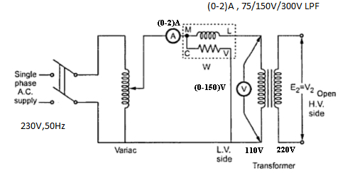

SC Test CIRCUIT DIAGRAM:

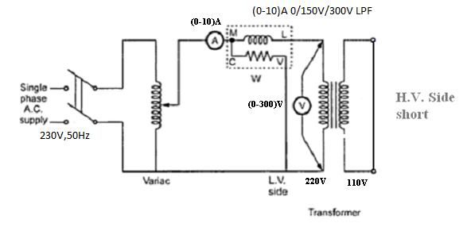

Procedure:

OC Test:

- Connections are done as per the circuit diagram.

- Supply is switched on and rated voltage is applied to the LV side by varying the Auto transformer.
- The readings of Ammeter, Voltmeter & Wattmeter are noted down.

SC Test:

- Connections are done as per the circuit diagram.

- Supply is Switched on and rated current is set through the HV winding by varying the Auto transformer.
- The readings of Ammeter, Voltmeter & Wattmeter are noted down.

Model graphs:

 |  | %Efficiency
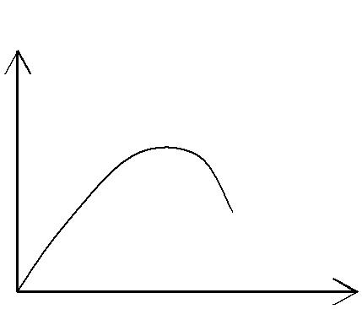  %Regulation |  | %Efficiency
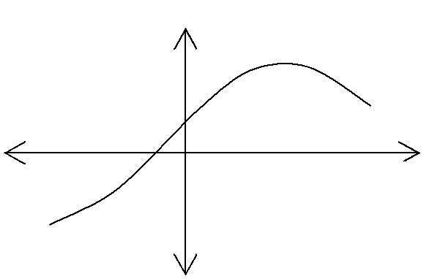

Power factor

Output power(W)

Observations:

O.C test:

V₀(V) | I₀(A) | W₀(watts)

Calculations:

Cosφ₀ = ^{W0} =
V₀ I₀

I_{W} = I₀Cosφ₀ =

I_{m} = I₀Sinφ₀ =

R₀ = ^{V0} =
I_{W}

X _{m} = | ^{V}0 | =
 | I_{m}

Note: The Transformer is taken as

Step up Transformer.

R₀₂ = ^{Wsc}

I_{sc} ²

Z₀₂ = ^{Vsc}

^{I}sc

S.C test:

V_{SC}(V) | I_{SC}(A) | W_{SC}(watts)

X ₀₂ = Z₀₂² − R₀₂² =

_{K} ₌ ^{N}2 ₌ ^{E}2 ₌

^{N}1 ^{E}1
X | 01 | = | ^{X} 02 | = | ; R | = | ^{R}02 | =
 | 01 |  | _{K} 2 |  | 01 |  | K ²

Efficency = |  |  | xV₂ I₂Cosθ₂ |  |  |  |  |  | ×100
Efficency = | xV | I | Cosθ | 2 | +W |  | +W |  | ×100
2 |  | 2 |  | 2 |  | i |  | sc
Where, x = Fraction o f Full loa d current

W = Iron losss |  | =W , W |  |  | sc | = Cu loss = x²W |  |  |  | sc
I |  |  | o |  | sc |  |  |  |  | sc
% Regulation = $\frac{I_{1}(R_{\text{01}}\text{Cos}φ±X_{\text{01}}\text{sin}φ)}{V_{1}}$
(or)
$\frac{I_{2}(R_{\text{02}}\text{Cos}φ±X_{\text{02}}\text{sin}φ)}{V_{2}}$
(+ for Lag pf ,− for Lead pf ) Where, Cosθ₂ = Load

Results:

Applications:
There are number of applications domestically as supply is single phase, it is very simple and cheaper to use single phase transformer to step up or down the voltage.
they are used-
+as VOLTAGE REGULATOR in television set ,
+as step-down transformer to reduce voltage level in mobile chargers,laptop chargers (the small
value of voltage is further converted into DC voltage to charge the battery)
+as step-up transformer in Inverters used at home.
and many more
There is a single phase transformer in the power supply of many domestic appliances. They are also used in audio equipment and radio frequency receivers and transmitters.

Viva Questions:
1. Why transformer rating is in KVA not KW?
2. What is SC test.
3. Explain why the wattmeter reading in O.C Test is taken as Iron Loss?
4. What is the name of the winding to which supply is given?
5. What is the name of the winding from which the supply is taken for load connections?
6. Which material is used for the core of a transformer and why?
7. What is the use of iron core in a transformer.
8. How is magnetic leakage reduced?
9. Why are iron cores in transformers made laminated?
10. What determines the thickness of the lamination or stamping?
11. Why are the laminations insulated from each other?
12. Why transformer rating is in KVA not KW.
13. What is called grain-oriented laminations?
14. What is the permissible maximum flux density in transformer core?
15. What is the phase relationship between the primary and secondary voltages of a transformer?
16. What is turn ratio of a transformer?
17. What is voltage ratio of a transformer?
18. What current flows in the transformer primary when its secondary is open?
19. What is the formula for calculating no-load current?
20. Why is the frequency not changed during transformation of electrical energy in a transformer?
21 What is the emf equation of a transformer?
22. What are the two basic types of transformers?
23. What are the types of transformers according to the arrangement of iron cores?
24. What magnetic circuit is formed in Berry-type constructions and why?
25. What is called limb of a transformer?
26. Why are LT windings placed near the core?
27. What are the types of windings according to the construction?
28. What is the difference between cylindrical-type and sandwich-type winding?
29. What are the types of transformers?
30 .What do you mean by step-up transformers?
31. What is an ideal transformer?
32. What do you mean by power transformer?
33. What do you mean by distribution transformers?
34. What do you mean by lighting transformer?
35. How does a transformer contribute towards the widespread popularity of AC system over
DC?
36. The required thickness of lamination in a transformer decreases when
37.Oil in transformers is used to -
38.What is the principle of operation of a Transformer?
39. What is the function of a Transformer?
40. What are the different types of a Transformer?
41. What are the different parts of a Transformer?
42. What are the different types of measuring instruments?
43. What is the principle of operation of a Transformer?
44. What is meant by “Pre determination” with respect to electrical machines?
45. What is meant by efficiency?
46. Can we start the motor without using three point starter? If so, how?
47. What is the purpose of Auto transformer (or Dimmer stat)?
48. Define regulation?
49. What do you mean by step-down transformers?
50. How many types transformers?

EXERCISE PROBLEMS

- A 230/2300V transformer takes no load current of 5A at 0.25pf lagging. Find i) the core loss ii) magnetizing current?
- A 3300/220v, 30 KVA, 1ф transformer takes no load current at 1.5Awhen the low voltage winding is open. The iron loss component is 0.4A. Find i) no load input power ii) magnetizing component iii) power factor of no load current
- A25KVA transformer has 500 turns on the primary and 50turns on the secondary winding. The primary is connected to 3000v 50Hz supply. Find the full load primary and secondary currents, the secondary emf And the maximum flux in the core .Neglect leakage drops and no load primary current.
- The efficiency of a 400KVA 1фtransformer is 98.77% when delivering full load at 0.8pf and 99.13% at half full load at unity power factor. Calculate i) Iron losses ii) 1/4th copper loss
- Calculate the % regulation of a transformer in which the % resistance drop is 1% and % reactance drop is 5% when the power factor 0.8 lagging ii) unity iii) 0.8leading.
- In a 50KVA transformer, the iron loss is 500MW and full load copper loss is 800W. Find the efficiency at full load and half full load at 0.8pf lag.
- A 50Hz, 1Ø, 100 KVA transformers has full load copper loss of 1300W and its iron loss is 860W. Calculate: The efficiency at full load, 0.8 power factor.
- A 50Hz, 1Ø, 150 KVA transformers has full load copper loss of 1200W and its iron loss is 760W. Calculate the efficiency at full load, 0.8 power factors.
- The efficiency of a 30KVA 1фtransformer is 97.77% when delivering full load at 0.8pf and 98.13% at half full load at unity power factor. Calculate i) Iron losses ii) copper loss iii) efficiency.

- A 230/150V transformer takes no load current of 5A at 0.25pf lagging. Find i) the core loss ii) magnetizing current?

- A 200/2200V transformer takes no load current of 6A at 0.25pf lagging. Find i) the core loss ii) magnetizing current?
- A 300/20v, 3KVA, 1ф transformer takes no load current at 1Awhen the low voltage winding is open. The iron loss component is 0.4A. Find i) no load input power ii) magnetizing component iii) power factor of no load current
- A 2KVA transformer has 400 turns on the primary and 60turns on the secondary winding. The primary is connected to 300v 50Hz supply. Find the full load primary and secondary currents, the secondary emf And the maximum flux in the core .Neglect leakage drops and no load primary current.
- The efficiency of a 40KVA 1фtransformer is 98.77% when delivering full load at 0.8pf and 99.13% at half full load at unity power factor. Calculate i) Iron losses ii) 1/4th copper loss
- Calculate the % regulation of a transformer in which the % resistance drop is 1% and % reactance drop is 5% when the power factor 0.8 lagging ii) unity iii) 0.8leading.
- In a 5KVA transformer, the iron loss is 50MW and full load copper loss is 80W. Find the efficiency at full load and half full load at 0.8pf lag.
- A 50Hz, 1Ø, 10 KVA transformers has full load copper loss of 130W and its iron loss is 86W. Calculate: The efficiency at full load, 0.8 power factor.
- A 50Hz, 1Ø, 150 KVA transformers has full load copper loss of 120W and its iron loss is 76W. Calculate the efficiency at full load, 0.8 power factors.
- The efficiency of a 30KVA 1фtransformer is 97.77% when delivering full load at 0.8pf and 98.13% at half full load at unity power factor. Calculate i) Iron losses ii) copper loss iii) efficiency.

- A 230/150V transformer takes no load current of 2A at 0.25pf lagging. Find i) the core loss ii) magnetizing current?

Expt. No.5

BRAKE TEST ON 3ᴓ- INDUCTION MOTOR

Aim: To conduct a brake test on the given 3-Slip ring Induction motor and to draw its performance Characteristics.

Required instruments:

S.No | Equipment | Range | Type | Qty
1 | Ammeter | (0-2)A | MI | 1No
2 | Voltmeter | (0-600)V | MI | 1No
3 | wattmeter | 0-150V/300V/600V/10A | UPF | 2NO
4 | Tachometer | 0-9999rpm | Digital | 1No
5 | Connecting wires

Precautions:
a) There should not be loose and wrong connections in the circuit
b) Three phase auto transformer should be in minimum output voltage position
c) Initially there should be no load on the motor
d) Apply water into brake drum during operation to control the heat of the brake drum.
f) Before making or breaking the circuit, supply must be switched OFF.

CIRCUIT DIAGRAM:-

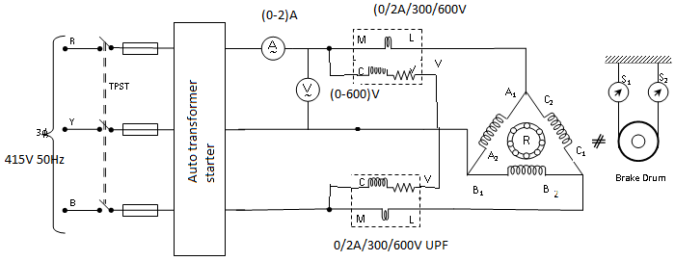
Expected graphs:-

Theory:

As a general rule, conversion of electrical energy to mechanical energy takes place in to the rotating part on electrical motor. In DC motors, electrical power is conduct directly to the armature, i.e, rotating part through brushes and commutator. Hence, in this sense, a DC motor can be called as ‘conduction motor’. However, in AC motors, rotor does not receive power by conduction but by induction in exactly the same way as secondary of a two winding T/F receives its power from the primary. So, these motors are
known as Induction motors. In fact an induction motor can be taken as rotating T/F, i.e, one in which primary winding is stationary and but the secondary is free.
The starting torque of the Induction motor can be increase by improving its p.f
by adding external resistance in the rotor circuit from the stator connected rheostat, the rheostat resistance being progressively cut out as the motor gathers speed. Addition of external resistance increases the rotor impedance and so reduces the rotor current. At first, the effect of improved p.f pre dominates the current-decreasing effect of impedance. So, starting torque is increased. At time of starting, external resistance is kept at maximum resistance position and after a certain time, the effect of increased impedance pre dominates the effect of improved p.f and so the torque starts decreasing. By this during running period the rotor resistance being progressively cut-out as the motor attains its speed. In this way, it is possible to get good starting torque as well as good running torque.

PROCEDURE:

    - Connections are made as per the circuit diagram.

    - The TPST switch is closed and the motor is started using auto transformer starter to run at rated voltage

    - At no load the speed, current, voltage and power are noted.

    - By applying the load, for various values of current the above-mentioned readings are noted.

    - The load is later released and the motor is switched off and the graph is drawn.

S no. | V  (Volt) | I_{L}  (Amp) | N  (rpm) | S1  (Kg) | S2  (Kg) | W=S1-S2 (Kg) | T= 9.81 W r  (Nm) | Output=  2πNT/60  (watts) | Input=  W1+W2 (Watts) | η = output/  Input (%) | (N_{s}-N)/N
  % Slip=
Tabular Column:

Model calculation:

- Radius, R = 105mm
- T= 9.81 W r N-m
- W=S1-S2 kg
- Output=2πNT/60 watts
- Input= W1+W2 watts
- η =output/input%
- slip=(N_{s}-N)/N

Result:

Application:
A three-phase induction motor is used to adopt and apply so many cases. I give some introduce real application in the manufacturing parts as bellows;
1. A three-phase induction motor is operated without any VFDs(Variable Frequency
Drive). In case of this, speed and torque that is happened are continuously same
from start to stop when it does not consider a starting torque. The cost that is
composed like this is very cheap. The examples that are similar to this are supply
and return fans of AHU (Air Handling Unit), circulation water pumps of HVAC, feed
water pump of fire extinguish and so on.
2. There are so many types of VFD (Variable Frequency Drive) in the market and they
are really well-made, cheaper and small. Therefore, most of electrical engineers
and customers want to adopt VFD in order to saving energy and control more
accuracy.

EXERCISE PROBLEMS
- 3 Φ 6 pole induction motor to 50 Hz supply, the voltage induced in the rotor bars is 4v, when the rotor is at stand still. Calculate the voltage a frequency induced in the rotor bars at 300 rpm.

- A 6 pole induction motor is fed by 3Φ 50Hz supply and running with a full load slip of 3%. Find the full load speed of induction motor and also the frequency of rotor emf.

- A 3Φ 6 pole induction motor is connected to 50 Hz supply the voltage induced in the rotor bars is 4 v. When the rotor is standstill calculate the voltage and frequency induced in the rotor bars at 300 rpm.

- A 6 pole induction motor is fed by 3Φ 50Hz supply and running with a full load slip of 3%. Find the full load speed of induction motor and also the frequency of rotor emf.

- A 3Φ 6 pole induction motor is connected to 50 Hz supply the voltage induced in the rotor bars is 4 v. When the rotor is standstill calculate the voltage and frequency induced in the rotor bars at 300

- 3 Φ 6 pole induction motor to 50 Hz supply, the voltage induced in the rotor bars is 4v. When the rotor is at standstill. Calculate the voltage a frequency induced in the rotor bars at 300 rpm.

- A slip ring induction motor runs at 290rpm at full load, when connected to 50Hz supply. Determine the no of poles and slip.

- A 4 pole 3ф induction motor operates from a supply whose frequency is 50Hz .Calculate the speed of the rotor when the slip is 0.04.

- A 4pole 3ф induction motor operates from a supply whose frequency is 50Hz .Calculate the frequency of the rotor currents when the slip is 0.03.

- 3ф induction motor is wound for 4 poles and is supplied from 50Hz system .Calculate i) The synchronous speed ii) a rotor speed when the slip is 4%.

- 3 Φ 4 pole induction motor to 50 Hz supply, the voltage induced in the rotor bars is 4v, when the rotor is at stand still. Calculate the voltage a frequency induced in the rotor bars at 300 rpm.

- A 6 pole induction motor is fed by 3Φ 50Hz supply and running with a full load slip of 5%. Find the full load speed of induction motor and also the frequency of rotor emf.

- A 3Φ 6 pole induction motor is connected to 50 Hz supply the voltage induced in the rotor bars is 6 v. When the rotor is standstill calculate the voltage and frequency induced in the rotor bars at 400 rpm.

- A 6 pole induction motor is fed by 3Φ 50Hz supply and running with a full load slip of 3.5%. Find the full load speed of induction motor and also the frequency of rotor emf.

- A 3Φ 6 pole induction motor is connected to 50 Hz supply the voltage induced in the rotor bars is 5v. When the rotor is standstill calculate the voltage and frequency induced in the rotor bars at 200

- 3 Φ 6 pole induction motor to 50 Hz supply, the voltage induced in the rotor bars is 4v. When the rotor is at standstill. Calculate the voltage a frequency induced in the rotor bars at 500 rpm.

- A slip ring induction motor runs at 190rpm at full load, when connected to 50Hz supply. Determine the no of poles and slip.

- A 6 pole 3ф induction motor operates from a supply whose frequency is 50Hz .Calculate the speed of the rotor when the slip is 0.44.

- A 4pole 3ф induction motor operates from a supply whose frequency is 50Hz .Calculate the frequency of the rotor currents when the slip is 0.3.

- 3ф induction motor is wound for 4 poles and is supplied from 50Hz system .Calculate i) The synchronous speed ii) a rotor speed when the slip is 2%.

Viva voice:

1. What is an Induction Motor?
2. What is an Electric Motor?
3. How to Supply Power To Rotor?
4. Why An Induction Motor Sometimes Called Rotating Transformer?
5. Who Invented Induction Motor?
6. What is The Basic Difference between Synchronous Motor and an Induction Motor?
7. Why Stator Windings Are Arranged Around The Rotor?
8. Why The Speed Of The Physical Rotor And The Speed Of The Rotating Magnetic Field In The Stator Must Be Different?
9. What is the Slip?
10. How Many types Of Induction Motor?
11. What is a Stator?
12. How Many types Of Rotor Are There?
13. What Techniques is Used to Produce a Desired Speed?
14. What is The Difference between Dc Motors and the Induction Motors?
15. How an Induction Motor Is Started? Why The Starter Is Used?
16. What is a Rotor?
17. What is Commutator?
18. What is an Armature?
19. What is a Cogging Torque?
20. What are the advantages of slip ring induction motor?
21. What are the differences between slip ring and squirrel cage rotors?
22. Why is an induction motor not capable of running at synchronous speed?
23. Why is it necessary to start an induction motor at reduced voltage?
24. Why Induction Machine always runs below synchronous speed
25. How direction of 3 phases Induction Motor can be changed
26. What are the different starting methods of 3 phase induction motor?
27. When we can get Maximum Torque in Induction Motor while starting?
28. What are the different losses in 3 phase induction motor?
29. What is the relation between torque and supply voltage in 3 phase induction motor?
30. What is the condition for maximum torque in induction motor?
32. What are the advantages of Induction Motors?
33. What are the disadvantages of Induction Motors?
34. Where do we require single-phase induction motors?
35. Why is the power factor of a single-phase induction motor low?
36. What is a fractional H.P. motor?
37. Which type of rotor is used in single phase motors?
38. How the starting winding produce rotation in a single phase resistance start induction motor?
39. How the starting winding is made resistive?
40. How the speed of rotation of a split phase induction motor is reversed?
41. What will happen if the centrifugal switch fails to open the starting winding?
42. How speed control is made in single phase motors?
43. Is there any relation between the capacitances of two capacitors used in two value capacitor motor?
44. What is size of shaded-pole motor?
45. Why shaded-pole single phase induction motor does not need any special starting technique like capacitors and auxiliary winding etc.
46. How can a universal motor be reversed?
47. What are applications of Stepper motors?
48. Why do we use capacitor-start induction motors in applications requiring high starting torque in preference to repulsion induction motors?
49.How many types of motors/
50.Wfrite the formula for synchronous impedance?

Expt. No.6

REGULATION OF ALTERNATOR BY SYNCHRONOUS IMPEDANCE
METHOD

Aim: To conduct OC test & SC test n the given 3-Alternator and to
Determine its regulation by synchronous impedance method.

Apparatus :

No | Equipment | Range | Type | Qty
1 | Ammeter | (0-2)A  (0-10)A | MC  MI | 1No  1No
2 | Voltmeter | (0-600)V | MI | 1No
3 | Rheostats | Wire wound | 370Ω/1.7A | 2No
4 | Tachometer | 0-9999 rpm | Digital | 1No

Theory:

1) Operate the 3-point starter slowly & uniformly.
2) Keep the speed of the prime mover to its rated value through
out the experiment.
3) In OC test, there should not be any load on Alternator.
4) In SC test, the SC current should not exceed its rated value.
Alternator is a machine, which converts mechanical energy to
Electrical energy. Regulation of an Alternator can be calculated by synchronous impedance method. In OC test the terminals of the alternator are kept opened and a voltmeter is connected. Keeping speed constant, a relation b/w field current & open circuit voltage are obtained. In SC test, the terminals are short circuited with a suitable ammeter & a relation b/w field current & short circuit Current are obtained.

Voltage regulation:

It is defined as the rise in terminal voltage of an isolated
Machine when full load is thrown off w.r.t voltage on the full load,
When speed & excitation remaining constant.
Now, Syn.Impedance (ZS) = OC voltage / SC current
XS =√ Z2S - R2a
From fig. EO = √OB2 + BD2
= √ (Vcos+IRa)2 + (Vsin+IXS)2
% Regulation = [(E0-V) / V] 100

Circuit diagram:

Procedure:

OC test:

1) Give all connections as per the circuit diagram.
2) switch-ON the supply & by varying the starter, prime mover
Speed is adjusted to rated.
3) Now keeping the field current at zero, note the induced emf in
Armature duo to residual Magnetism.
4) By slowly varying the potential divider, field current is increased
& corresponding emf Induced is noted up to above 20% of rated voltage.
SC test:

1) Give all connections as per the circuit diagram.
2) switch-ON the supply & by varying the starter, prime mover
Speed is adjusted to rated.
3) By slowly varying the potential divider, field current is increased
& corresponding short Circuit current is noted up to rated value.
To find armature resistance (Ra):
Give the connections as per diagram and by slowly varying the
Rheostat, note the values of ammeter & voltmeter up to some value and average them.

Graph:

1) A graph is drawn b/w If and V which is known as OC
Curve, by taking If on X-axis and V on Y-axis.
2) A graph is drawn b/w If and ISC which is known as SC curve, by Taking If on X-axis and I_{SC}V on Y-axis.

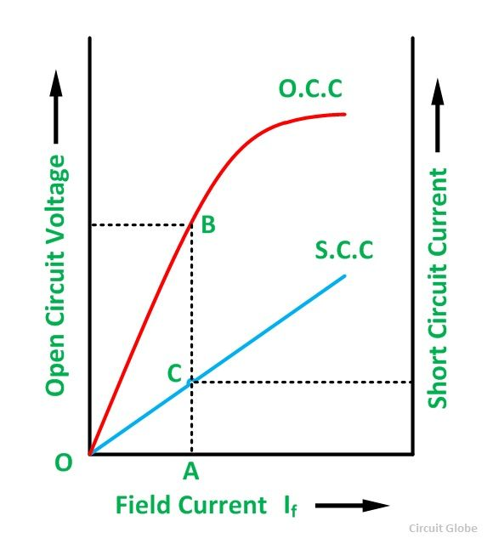

Tabular Column:

OC TEST:
Field current | OC Voltage

SC TEST:
Field current | SC Current

Result:

Application:
  - cylindrical rotor machine
  - lower excitations
  - wind turbines
  - buck - boost regulator

The main advantages of this method are the value of synchronous impedance Z_{s} for any load condition can be calculated. Hence regulation of the alternator at any load condition and load power factor can be determined. Actual load need not be connected to the alternator and hence method can be used for very high capacity alternators.
The main limitation of this method is that the method gives large values of synchronous reactance. This leads to high values of percentage regulation than the actual results. Hence this method is called pessimistic method
Viva questions:
- What is meant by voltage regulation?

- What is meant by Synchronous Impedance?

- What is OC test ?

- What is SC test?

- What is meant by mmf or field ampere turns?

- What is basic the principle of operation of an alternator

- Why an alternator is called synchronous generator

- List the different types of alternators

- List the advantages of rotating field system in alternators

- Why the pole shoes of salient pole machines are chamfered

- Which type of alternators are used in hydro electric power plants

- Differentiate between full pitched and short pitched winding.

- List the advantages of short pitched winding.

- What is meant by armature reaction?

- What is meant by predetermination of regulation?

- Why almost all large size Synchronous machines are constructed with rotating field system type?
- Name the types of Alternator based on their rotor construction.

- Why do cylindrical Alternators operate with steam turbines?

- What are the advantages of salient pole type construction used for Synchronous machines?

- How does electrical degree differ from mechanical degree?

- Frequency generated in a 8-pole alternator that rotates at 750 r.p.m is?

- Define pole pitch?
- What is short pitch winding?
- Define pitch factor or coil span factor?
- Why is short pitch winding preferred over full-pitch winding ?
- What is distributed winding?
- what is slot angle β?
- Why are Alternators rated in kVA and not in kW?
- What is meant by armature reaction in Alternators?
- Alternator operates on the principle of ?
- In modern alternators, the rotating part is ?
- Salient pole field structure has the advantages of ?
- What are the two types of turbo-alternators ?
- How do you compare the two ?
- What is direct-connected alternator ?
- What is the difference between direct-connected and direct-coupled units ?
- Why Alternator is called Synchronous generator?
- Why a 3-phase synchronous machine will always run at synchronous speed?
- What are the essential features of synchronous machine?
- Why almost all large size Synchronous machines are constructed with rotating field system type?
- Write down the equation for frequency of emf induced in an Altenator?
- How are alternators classified?
- Why do cylindrical Alternators operate with steam turbines?
- Which type of pole generators are used in Hydro-electric plants and why?
- State three important features of turbo alternator rotors?
- What are the advantages of salient pole type of construction used for synchronous machines?
- Mention the uses of damper windings in a synchronous machine?
- Why is the stator core of Alternator laminated?
- How does electrical degree differ from mechanical degree?
- What is the relation between electrical degree and mechanical degree?

EXERCISE PROBLEMS:

1. Calculate the distribution factor of a 3-phase winding with 120° phase –spread when the winding is 1) uniformly distributed.2)occupies6 slots per poles
2. Calculate the open circuit voltage of a 3phase, star-connected alternator, 4 pole, 60Hz, 120 slots with each slot having 6 conductors in two layers. The machine is running at 1800rpm with a flux per pole of 125 millimeter. The coil span is 12.
3. Calculate the open circuit voltage of a 3phase, star-connected alternator, 6 pole, 60Hz, 60 slots with each slot having 6 conductors in two layers. The machine is running at 1800rpm with a flux per pole of 120 milliWeber. The coil span is 6

4.A 750kVA, 2300V, delta-connected, 3-phase alternator has had open and short circuit tests performed and the following date were obtained: Short Circuit test Field current = 31.5A Line current = rated Open-circuit test Field-current = 31.5A Line voltage=1050V The dc resistance across the terminals was measured at 0.38 ohm. Calculate the V.R. at 0.8pf lagging.
5. A 500kVA, 2000V, delta-connected, 3-phase alternator has had open and short circuit tests performed and the following date were obtained: Short Circuit test Field current = 15.5A Line current = rated Open-circuit test Field-current = 15.5A Line voltage=1000V The dc resistance across the terminals was measured at 0.38 ohm. Calculate the V.R. at 0.8pf lagging.
6. Calculate the distribution factor of a 3-phase winding with 60° phase –spread when the winding is 1) uniformly distributed.2)occupies 8 slots per poles
7. Calculate the open circuit voltage of a 3phase, star-connected alternator, 4 pole, 60Hz, 120 slots with each slot having 6 conductors in two layers. The machine is running at 1800rpm with a flux per pole of 125 milliWeber. The coil span is 12.
8. A single phase alternator, 50kVA, 460V supplies the rated load at 0.88 pf lagging. The dc resistance across the terminals ais 0.5 ohm and the synchronous reactance is 2.5 ohm. Calculate the angle of the power.
9. A single phase alternator, 25kVA, 460V supplies the rated load at 0.88 pf lagging. The dc resistance across the terminals ais 0.05 ohm and the synchronous reactance is 0.5 ohm. Calculate the angle of the power.
10. A single phase alternator, 200kVA, 430V supplies the rated load at 0.8 pf lagging. The dc resistance across the terminals ais 0.2 ohm and the synchronous reactance is 3.5 ohm. Calculate the angle of the power.
11. Calculte the distribution factor of a 3-phase winding with 90° phase –spread when the winding is 1) uniformly distributed.2)occupies 12 slots per poles
12. Find the number of armature conductors in series per phase required for 3 phase, 10 pole alternator when driven at a speed of 600 RPM. Armature has 90 slots and armature winding is star connected to give induced emf of 11KV between lines. Assume flux per pole as 16 mwb.
13. A single phase alternator, 400kVA, 430V supplies the rated load at 0.6 pf lagging. The dc resistance across the terminals ais 0.3 ohm and the synchronous reactance is 3.0 ohm. Calculate the angle of the power.
14. Find the number of armature conductors in series per phase required for 3 phase, 8 pole alternator when driven at a speed of 500 RPM. Armature has 40 slots and armature winding is star connected to give induced emf of 10KV between lines. Assume flux per pole as 10 mwb
15. Find the number of armature conductors in series per phase required for 3 phase, 8 pole alternator when driven at a speed of 1000 RPM. Armature has 40 slots and armature winding is star connected to give induced emf of 20KV between lines. Assume flux per pole as 5 mwb.
16. A single phase alternator, 1200kVA, 430V supplies the rated load at 0.8 pf lagging. The dc resistance across the terminals ais 0.25ohm and the synchronous reactance is 7.5 ohm. Calculate the angle of the power.
17. Calculte the distribution factor of a 3-phase winding with 110° phase –spread when the winding is 1) uniformly distributed.2)occupies 10 slots per poles
18. Calculte the distribution factor of a 3-phase winding with 120° phase –spread when the winding is 1) uniformly distributed.2) occupies 18 slots per poles.
19. A 750kVA, 2000V, delta-connected, 3-phase alternator has had open and short circuit tests performed and the following date were obtained: Short Circuit test Field current = 15.5A Line current = rated Open-circuit test Field-current = 15.5A Line voltage=1000V The dc resistance across the terminals was measured at 0.5 ohm. Calculate the V.R. at 0.6pf lagging.
20. Calculate the open circuit votlage of a 3phase, star-connected alternator, 4 pole, 60Hz, 120 slots with each slot having 6 conductors in two layers. The machine is running at 1800rpm with a flux per pole of 125 milliWeber. The coil span is 12.

Expt. No.7
Load test on a 1-φ transformer

Aim: To perform conduct Load test on the given 1-Φ Transformer and to calculate its, Efficiency and Regulation.

Name plate details:

1-φ TRANSFORMER
Capacity | 2KVA
I/P voltage | 220V
I/P current | 26A
O/P voltage | 220V
O/P current | 13A
Frequency | 50Hz

Apparatus required:

 | S.No | Apparatus | Range | Type | Qty
 | 1 | Voltmeters | 0-150V, 0-75V | M.I | 1, 1 No
 | 2 | Ammeters | 0-2A, 0-15A | M.I | 1,1 No
 | 3 | Wattmeter | 2A, 150V, 60W, LPF | Dynamo meter | 1, 1 No
 | 3 | Wattmeter | 15A, 50V, 600W, UPF |  | 1, 1 No
 | 4 | Auto T/F | 230V/0-270V | 1-φ wire wound | 1 No

Theory:

In a practical transformer there are two types of losses:
(1) Cu loss
(2) Core/Iron loss.
Therefore output of a transformer is always less than input of the transformer.
Here transformer is loaded with a variable resistive load. Input to the transformer can be found out by using a wattmeter and output can also be measured by a wattmeter or with the help of voltmeter and ammeter.

Input power to transformer = Reading of wattmeter

Output power from transformer = V2I2 [QCosΦ2 = load P.F = 1]

% efficiency η = (Output Power / Input Power) × 100%

= (V2I2 / W1) × 100%

Voltage regulation (V.R) is the change in the magnitude of secondary voltage from no load to desired load.
This change is expressed as a percentage of the no load voltage.

% V.R. = *100 %

= *100%

= E₂/E₂-V

Where: - E2 = No load voltage

V2 = any load voltage

This voltage regulation is because of resistance and leakage reactance of the transformer

CIRCUIT DIAGRAM:
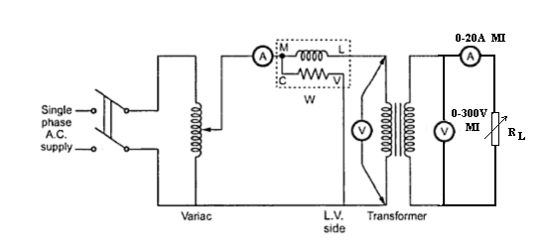

MODEL GRAPHS:

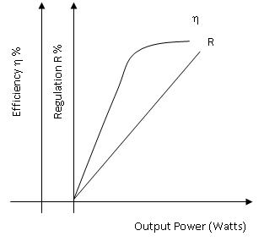

Procedure:

- Connections are made as per the circuit diagram.

- By varying the Auto transformer, rated voltage is applied to the input side of the transformer and should be maintained constant throughout the experiment.

- By varying the load in steps, readings of ammeter, voltmeter, and wattmeter are noted down in each step.

- Efficiency and Regulations are calculated in each step and tabulated.

- Graphs are drawn Output Vs Efficiency and Regulation

FORMULAS:

Input Power = W₁ x Multiplication factor
Output Power = W₂ x Multiplication factor

Efficiency η % = Output Power ÷ Input Power ×100

V_{NL} - V_{FL} (Secondary)
Regulation R % = ______________________ x 100%
V_{NL}

Tabular column:

Rated Secondary Voltage, V₂=230V

S.NO | Sec voltage V¹(v) | Voltage (v) | Sec current I₂(A) | Input power(w) | Output power=  V₂×I₂ (w) | Efficiency η =P_{output}/P_{input}

Model calculation:

Precautions:

1. The Dimmer stat should be kept at minimum O/P position initially.

2. Rated voltage should be maintained on the Primary of the Transformer.

3. The Dimmer stat should be varied slowly & uniformly.

Result:

Applications:
The most important uses and application of Transformer are:
1. It can rise or lower the level of level of Voltage or Current ( when voltage increases, current decreases and vice virsa because P =V x I, and Power is same ) in an AC Circuit.
2. It can increase or decrease the value of capacitor, an inductor or resistance in an AC circuit. It can thus act as an impedance transferring device.
3. It can be used to prevent DC from passing from one circuit to the other.
It can isolate two circuits electrically

Viva Questions:

1. Define power factor of a transformer at no load?.
2. What is the normal phase difference between the voltage and the no-load current in a transformer?
3. Describe the essential parts of a transformer?
4. What is the name of the winding to which supply is given?
5. What is the name of the winding from which the supply is taken for load connections?
6. Which material is used for the core of a transformer and why?
7. What is the use of iron core in a transformer?
8. How is magnetic leakage reduced?
9. Why are iron cores in transformers made laminated?
10. What determines the thickness of the lamination or stamping?
11. Why are the laminations insulated from each other?
12. What is stacking factor? What is its approximate value?
13. What is called grain-oriented laminations?
14. What is the permissible maximum flux density in transformer core?
15. What is the phase relationship between the primary and secondary voltages of a transformer?
16. What is turn ratio of a transformer?
17. What is voltage ratio of a transformer?
18. What current flows in the transformer primary when its secondary is open?
19. What is the formula for calculating no-load current?
20. Why is the frequency not changed during transformation of electrical energy in a transformer?
21 What is the emf equation of a transformer?
22. What are the two basic types of transformers?
23. What are the types of transformers according to the arrangement of iron cores?
24. What magnetic circuit is formed in Berry-type constructions and why?
25. What is called limb of a transformer?
26. Why are LT windings placed near the core?
27. What are the types of windings according to the construction?
28. What is the difference between cylindrical-type and sandwich-type winding?
29. What are the types of transformers?
30 .Describe step-up transformers?
31. Perform an ideal transformer?
32. What do you mean by power transformer?
33. What do you mean by distribution transformers?
34. What do you mean by lighting transformer?
35. How does a transformer contribute towards the widespread popularity of AC system over
DC?
36. The required thickness of lamination in a transformer decreases when
37.Oil in transformers is used to -
38.What is the principle of operation of a Transformer?
39. What is the function of a Transformer?
40. What are the different types of a Transformer?
41. What are the different parts of a Transformer?
42. What are the different types of measuring instruments?
43. What is the principle of operation of a Transformer?
44. What is meant by “Pre determination” with respect to electrical machines?
45. What is meant by efficiency?
46. Can we start the motor without using three point starter? If so, how?
47. What is the purpose of Auto transformer (or Dimmer stat)?
48. Define regulation?
49. What do you mean by step-down transformers?
50. How many types transformers?
EXERCISE PROBLEMS

- A 230/2300V transformer takes no load current of 5A at 0.25pf lagging. Find i) the core loss ii) magnetizing current?
- A 3300/220v, 30 KVA, 1ф transformer takes no load current at 1.5Awhen the low voltage winding is open. The iron loss component is 0.4A. Find i) no load input power ii) magnetizing component iii) power factor of no load current
- A25KVA transformer has 500 turns on the primary and 50turns on the secondary winding. The primary is connected to 3000v 50Hz supply. Find the full load primary and secondary currents, the secondary emf And the maximum flux in the core .Neglect leakage drops and no load primary current.
- The efficiency of a 400KVA 1фtransformer is 98.77% when delivering full load at 0.8pf and 99.13% at half full load at unity power factor. Calculate i) Iron losses ii) 1/4th copper loss
- Calculate the % regulation of a transformer in which the % resistance drop is 1% and % reactance drop is 5% when the power factor 0.8 lagging ii) unity iii) 0.8leading.
- In a 50KVA transformer, the iron loss is 500MW and full load copper loss is 800W. Find the efficiency at full load and half full load at 0.8pf lag.
- A 50Hz, 1Ø, 100 KVA transformers has full load copper loss of 1300W and its iron loss is 860W. Calculate: The efficiency at full load, 0.8 power factor.
- A 50Hz, 1Ø, 150 KVA transformers has full load copper loss of 1200W and its iron loss is 760W. Calculate the efficiency at full load, 0.8 power factors.
- The efficiency of a 30KVA 1фtransformer is 97.77% when delivering full load at 0.8pf and 98.13% at half full load at unity power factor. Calculate i) Iron losses ii) copper loss iii) efficiency.

- A 230/150V transformer takes no load current of 5A at 0.25pf lagging. Find i) the core loss ii) magnetizing current?

- A 200/2200V transformer takes no load current of 6A at 0.25pf lagging. Find i) the core loss ii) magnetizing current?
- A 300/20v, 3KVA, 1ф transformer takes no load current at 1Awhen the low voltage winding is open. The iron loss component is 0.4A. Find i) no load input power ii) magnetizing component iii) power factor of no load current
- A 2KVA transformer has 400 turns on the primary and 60turns on the secondary winding. The primary is connected to 300v 50Hz supply. Find the full load primary and secondary currents, the secondary emf And the maximum flux in the core .Neglect leakage drops and no load primary current.
- The efficiency of a 40KVA 1фtransformer is 98.77% when delivering full load at 0.8pf and 99.13% at half full load at unity power factor. Calculate i) Iron losses ii) 1/4th copper loss
- Calculate the % regulation of a transformer in which the % resistance drop is 1% and % reactance drop is 5% when the power factor 0.8 lagging ii) unity iii) 0.8leading.
- In a 5KVA transformer, the iron loss is 50MW and full load copper loss is 80W. Find the efficiency at full load and half full load at 0.8pf lag.
- A 50Hz, 1Ø, 10 KVA transformers has full load copper loss of 130W and its iron loss is 86W. Calculate: The efficiency at full load, 0.8 power factor.
- A 50Hz, 1Ø, 150 KVA transformers has full load copper loss of 120W and its iron loss is 76W. Calculate the efficiency at full load, 0.8 power factors.
- The efficiency of a 30KVA 1фtransformer is 97.77% when delivering full load at 0.8pf and 98.13% at half full load at unity power factor. Calculate i) Iron losses ii) copper loss iii) efficiency.

- A 230/150V transformer takes no load current of 2A at 0.25pf lagging. Find i) the core loss ii) magnetizing current?

